 **Effective Communication Tools for Teachers**

*Participant Manual*

****

Student Files (in course order)

History of Flight Timeline

Interview with Former Astronaut

Diameter of the Moon

Full Moon

What is Thrust?

Goddard’s First Rocket

History of Flight Timeline Spreadsheet

Robert Goddard bio

The Moon Adding Sounds

Whistling Wind

Despertar

The Moon Adding Video

Robert Goddard Bio Sounds

The Moon Audio and Video

Moon Newsletter Article

Moon Walk Video

Goddard Newsletter Article

Boomy Blast

Brown Bear

Facts about the Moon

Integration Project Files

Integration Unit Plan

Trademarks

Microsoft®, Windows®, Microsoft Office 2007®, Share Point®, Office Live Workspace®, Windows Live TM , Excel®, Word®, PowerPoint®, One Note®, Live Mesh® and Sky Drive TM are either registered trademarks or trademarks of Microsoft Incorporated in the United States and/or other countries. Microsoft product screen shots are reprinted with permission from Microsoft Incorporated.

Disclaimer

While Knowledge Network Solutions, Inc. is conscientious in its efforts to ensure the accuracy of this student manual, no warranty is provided regarding the effectiveness, accuracy, or suitability of the material contained in this manual.

Copyright

This student manual is copyrighted by Knowledge Network Solutions, Inc. with all rights reserved. This student manual and any relevant student files may not be reproduced in any form or by any means without the prior written permission of Knowledge Network Solutions, Inc.

Table of Contents

[Setting the Stage: Introduction 9](#_Toc233451544)

[Setting the Stage: Introduction 10](#_Toc233451545)

[What is Project Based Learning? 10](#_Toc233451546)

[Exploration – Discussing Project-based Learning 13](#_Toc233451547)

[Effective Communication Tools for Educators 14](#_Toc233451548)

[Integration Project Unit Plan 15](#_Toc233451549)

[Unit 1: Establishing a Foundation for Communications 21](#_Toc233451550)

[Establish a Foundation for Communications 22](#_Toc233451551)

[Navigating Windows Vista Ultimate 23](#_Toc233451552)

[Explore: Windows Vista Ultimate Extras 23](#_Toc233451553)

[Explore: Communicate with images using the Snipping Tool® 25](#_Toc233451554)

[Explore: Setting Up a Project Workspace using MS Office Live® 25](#_Toc233451555)

[Explore: Sharing Your Workspace and Documents with Team Members 28](#_Toc233451556)

[Test Your Knowledge 29](#_Toc233451557)

[Curriculum Connections 30](#_Toc233451558)

[Unit 2: Brainstorm, Capture and Organize 33](#_Toc233451559)

[Brainstorm, Capture and Organize 34](#_Toc233451560)

[Working with MS Office One Note 2007 34](#_Toc233451561)

[Research Findings on One Note and Learning Styles 35](#_Toc233451562)

[Brainstorm, Collect and Organize 36](#_Toc233451563)

[Explore: Creating a Notebook in MS Office One Note 2007 36](#_Toc233451564)

[Explore: Creating Notebook Sections 37](#_Toc233451565)

[Explore: Insert and Customize Tags in your notebook 38](#_Toc233451566)

[Explore: Incorporating Audio Files into Your Notebook 40](#_Toc233451567)

[Explore: Incorporate Screenshots into Your Notebook 40](#_Toc233451568)

[Test Your Knowledge 42](#_Toc233451569)

[Curriculum Connections 43](#_Toc233451570)

[Unit 3: Using MS Office Templates 45](#_Toc233451571)

[Using MS Office Templates 46](#_Toc233451572)

[Accessing and Using MS Word Templates 46](#_Toc233451573)

[Using Excel to Visually Communicate a Timeline 48](#_Toc233451574)

[Explore: Build a History of Flight Timeline with Excel Templates 49](#_Toc233451575)

[Creating a Presentation with MS PowerPoint Templates 52](#_Toc233451576)

[Using One Note Templates 53](#_Toc233451577)

[Test Your Knowledge 54](#_Toc233451578)

[Curriculum Connections 55](#_Toc233451579)

[Unit 4: Communicating with MS Learning Essentials 57](#_Toc233451580)

[MS Learning Essentials 58](#_Toc233451581)

[Overview: Tools for Teachers 58](#_Toc233451582)

[Overview: Tools for Students 59](#_Toc233451583)

[Overview: Content from Publishers 59](#_Toc233451584)

[Overview: Create New Content 60](#_Toc233451585)

[Using Learning Essentials to Communicate 61](#_Toc233451586)

[Explore: Create a Rubric Using Learning Essentials for Teachers 61](#_Toc233451587)

[Explore: Creating a Project 62](#_Toc233451588)

[Learning Essentials for Students 64](#_Toc233451589)

[Explore: Using Learning Essentials Presentation Templates 64](#_Toc233451590)

[Explore: Using a Report Template 66](#_Toc233451591)

[Test Your Knowledge 67](#_Toc233451592)

[Curriculum Connections 68](#_Toc233451593)

[Unit 5: Using Audio and Video to Enhance Communications 70](#_Toc233451594)

[Using Audio and Video to Enhance Communications 71](#_Toc233451595)

[Incorporating Audio and Video into PowerPoint 72](#_Toc233451596)

[Explore: Add and Manage Sounds in your Presentation 73](#_Toc233451597)

[21st Century Communications with Microsoft Zune® 73](#_Toc233451598)

[Explore: Using Zune to Communicate and Share 74](#_Toc233451599)

[Using Windows Media Player® to Enhance Communications 74](#_Toc233451600)

[Explore: Add a movie 75](#_Toc233451601)

[Test Your Knowledge 76](#_Toc233451602)

[Curriculum Connections 77](#_Toc233451603)

[Unit 6: Present and Publish 79](#_Toc233451604)

[Present and Publish 80](#_Toc233451605)

[Using Microsoft PowerPoint to Present the Project 81](#_Toc233451606)

[Explore: Combining Data from Multiple Sources into a Presentation 81](#_Toc233451607)

[Explore: Record Presentation as a Video and Share. 82](#_Toc233451608)

[Putting It All Together – The Newsletter 83](#_Toc233451609)

[Explore: Creating a Newsletter Template in MS Word 84](#_Toc233451610)

[Explore: Adding Content to the Newsletter Template 86](#_Toc233451611)

[TEst Your Knowledge 89](#_Toc233451612)

[Curriculum Connections 90](#_Toc233451613)

[Unit 7: Tying It All Together 92](#_Toc233451614)

[Tying It All Together 93](#_Toc233451615)

[Case Studies 93](#_Toc233451616)

[Explore: Case Study #1 93](#_Toc233451617)

[Explore: Case Study #2 95](#_Toc233451618)

[Explore: Case Study # 3 97](#_Toc233451619)

[Appendix: Resources for Project Based learning 99](#_Toc233451620)

[Select Online Resources for Project Based Learning 100](#_Toc233451621)

[References on Project Based Learning 101](#_Toc233451622)

Setting the Stage: Introduction

Course Objectives

Describe Effective Project Based Learning Experiences

Identify the Five Design Principles of Project Based Learning

Explain the Relationships between Effective Communications and Project Based Learning

Identify Microsoft® and MS Office 2007® Tools Available for Implementation of Project Based Learning

Setting the Stage: Introduction

Sit tight! Fasten your seat belts. It’s the 21st Century! Have you seen the new classrooms of the 21st century? There are no walls, no buildings, and no geographical limitations to accessing information. You probably already knew that, but did you know that collaborative student projects can also transcend those traditional barriers?

Microsoft® developed the tools. You can facilitate the projects!

What is Project Based Learning?

While “doing projects” is not a new concept in education, Project Based Learning (PBL) as a unique instructional methodology has emerged in only the past 30 years. With generally less structure than traditional teacher-led activities, PBL is known for its emphasis on student organization, time management, collaboration (often across disciplines), and construction of products (artifacts) to represent what is learned.

A generally accepted definition for Project Based Learning does not exist, but experts do agree that PB is flexible and fits within a wide range of settings. Project implementation can range from a single subject area to across disciplines, from one classroom to broad community involvement, from students in a single grade level to adults outside the school, and any combination of these.

Project Based Learning for 21st Century Skills

Project Based Learning is one way for students to develop 21st century skills, those skills that business leaders and policymakers identify as crucial for a service-oriented, entrepreneurial, and global workplace:

* Higher order and critical thinking skills for problem solving.
* Communication in a variety of modes.
* Use of technologies to complete tasks.
* Ability to analyze, synthesize, and create. (Sawchuk, 2009)

Project Based Learning aids the development of 21st century skills by supporting multiple learning styles and intelligences, providing opportunities for cross-curricular connections, and addressing more than one standard within the framework of a single project. Students are also more likely to remember concepts because they engage in project management and investigate topics using multiple strategies. Your students will learn to apply skills and concepts rather than just memorizing them for a test (Stearns & Shay, 2008).

Elements of a Good Project Based Learning Experience

More important than a “one size fits all” definition for PBL is a description of what elements provide a good Project Based Learning experience for your students:

* Students are at the center of the learning process as recognition of their inherent desire to learn, their ability to do important work, and their need to be taken seriously.
* Students engage with the central concepts and principles of a discipline. The project work is central rather than incidental to the curriculum.
* Students investigate provocative issues or questions that lead them to in-depth exploration of real-world, important topics.
* Essential tools and skills, including technology, facilitate learning, self-management, and project management.
* Specific products that solve problems, explain dilemmas, or present information are generated through investigation, research, or reasoning.
* Projects yield multiple products that permit frequent feedback and consistent opportunities for students to learn from experience.
* Performance-based assessments communicate high expectations, present rigorous challenges, and require a range of skills and knowledge.
* Students collaborate in some form, either through small groups, student-led presentations, or whole-class evaluations of project results. (Markum, Mergendoller, Larmer, & Ravitz, 2003)

The body of research on Project Based Learning is growing and supports its use to cut absenteeism, increase motivation, and improve standardized test scores (Edutopia, 2001).

The Principles of Design in Project Based Learning

Planning for PBL is based on five dynamic principles, illustrated in Figure 1 below and briefly described in the following narrative.

**Design Principle #2:**

**Develop the**

**Driving Question**

**Design Principle #5:**

**Manage the**

**Process**

**Design Principle #1:**

**Begin with the**

**End in Mind**

**Design Principle #4:**

**Map the**

**Process**

**Design Principle #3:**

**Plan the**

**Assessment**

Figure 1. Design Principles of Project Based Learning

**Design Principle #1: Begin with the End in Mind**

Conceptualizing the project by its goal helps students understand the rationale and meaning behind what they are asked to do. They will retain more information, be more motivated to participate, and will be able to apply their knowledge more skillfully. Some examples of end goals you might identify include

* To create individual investment portfolios, with accompanying business plans and product prototype.
* To educate the public about point source pollution.
* To understand the underlying causes of the Civil War. (Moursund, 2003)

**Design Principle #2: Develop the Driving Question**

A good driving question addresses authentic concerns and focuses on the application of content within the real world. Good questions require students to draw upon content and personal experiences, lead to other questions posed by students, and are deliberately thought-provoking, counterintuitive, and sometimes controversial (Greece Central School District).

**Design Principle #3: Plan the Assessment**

Project assessments should come in multiple forms, with activities that are diverse enough to include all students, yet specific enough to provide relevant and meaningful. Think about the process of triangulation:

* **Multiple assessors**. Students, peers, the teacher, and mentors.
* **Multiple units of assessment**. Individual students, groups, the whole class.
* **Multiple formats**. Written work (formal assignments and informal journal entries), observations (of group activities and individual work), presentations, informal discussions and questions, project designs, and the final media product (San Mateo Board of Education, 2001).

Expect your students to master the core content, conventions, and vocabulary of a topic.

**Design Principle #4: Map the Project**

Similar to a lesson plan, the project map helps you identify skills students need to perform, develop a timeline, and identify resources necessary to project implementation.

**Design Principle #5: Manage the Process**

The teacher as facilitator must be able to guide students through ®the learning process as well as keep the project focused and moving forward. You may have to learn or hone these skills as part of your own introduction to PBL.

Source, Figure 1 and Primary Source, Design Principle Information: (Buck Institute for Education and Boise State University, 2003)

Other Major Elements of Project Based Learning

There are several other major elements of PBL that you will want to include as you design your PBL unit. These include the following beyond the essential question: collaboration, communication, critical thinking, inquiry learning, and synthesis. These elements are addressed individually during the four Microsoft EXPAND modules.

Exploration – Discussing Project-based Learning

* List some projects that you currently have your students complete.
* List the skills that the students master by completing one of the projects.
* Do any of the projects involve opportunities for collaborative work?
* Are any of the projects long term projects?
* Do any of the projects address essential questions or introduce problems to be solved?
* Are the projects student-centered?
* Do any of the projects involve real-world issues or skills?
* How are the projects assessed?
* How would adding a technology component help the students better complete their projects? Better master the objectives?

Communication is an important component of Project Based Learning—between students, between students and teachers, and conceivably between students and other community members (San Mateo Board of Education, 2001). The following section describes how communication for effective project implementation is enhanced through Microsoft applications and tools.

Effective Communication Tools for Educators

Humans have been communicating since the beginning of time, ranging from very subtle processes of exchange to full conversations and mass communication. It all started with speech about 200,000 years ago, followed by the use of symbols about 30,000 years ago, and writing about 7,000 years ago.

21st Century communications involve an image rich environment that can share an idea, educate, entertain and inform, all within a single page or document. Throughout this course you will engage in a variety of activities to produce a dynamic document, using several technologies to design, organize, edit, collaborate and share the final result. Following is a brief explanation of how Microsoft applications and tools will be used as you explore effective communications in Project Based Learning:

MS Windows Vista Ultimate®

Navigate through Windows Vista Ultimate, a dynamic, image-rich environment with many interactive elements, as you complete a project and work with a variety of documents.

MS Office Live Workspace®

Team members work in a shared workspace for planning, organizing, sharing of documents, and communication using MS Office Live Workspace.

MS Office One Note 2007®

Brainstorm with team members to gather ideas, stories, and images in MS Office One Note 2007, a “digital 3-ring binder.” Capture and organize your entire project!

Learning Essentials 2.0 for MS Office®

Create, edit, and publish a project using Learning Essentials 2.0 for Microsoft Office. Work with original data or written materials, or use existing high quality Office templates.

Microsoft Zune®

Integrate audio and video files into your project with Microsoft Zune.

MS Office Excel 2007®

Build a project work timeline and add it to a document using MS Office Excel.

MS Office PowerPoint 2007®

Once your project is completed, present it for review using MS Office PowerPoint.

Project Based Learning will be the focus as you engage in activities to create an electronic school newsletter. Your experiences will involve multiple curriculum areas, varied technologies, and collaboration between you and your team members. To get started, examine the following integrated project unit plan.

Integration Project Unit Plan

| KNS  For Standards-based, Student-centered, Technology-rich Learning | Teacher: | Sandra Reddington |
| --- | --- | --- |
| School/District: | Leaders Mill Middle School |
| Subject Area(s) Addressed: | Science |
| Grade Level(s)/Course: | 8th |
| Date Submitted: | July 1, 2009 |
| Unit Duration: | 10 50-minute class periods |

|  |  |  |
| --- | --- | --- |
| Unit Title | **Creating Electronic Communications: The Space Day Project** | |
| General Unit  Outcomes | Students have been working on how to write lab reports based on observations, but have not focused on design and style. They will be learning to enhance the content and appeal of science content through audio and visual enhancements.   1. Work collaboratively to plan, design, create, write, and publish an electronic school newsletter. 2. Use integrated word processing, publishing, and presentation applications with many of their formatting, style, and editing tools to complete their assigned article throughout the writing process (brainstorming, prewriting, drafting, revising, editing, and publishing). 3. Use a note taking and organizational application to manage the project. 4. Manage and publish audio and video files and incorporate them into the project. 5. Use database and/or spreadsheet applications, the Internet, digital cameras, magazines and newspapers, library resources, community resources, and school resources to complete the project. | |
| **Academic Standards Addressed (List source & #)** | **Standards for the English Language Arts: NCTE and IRA (http://www.ncte.org/about/over/standards/110846.htm)**  2. Students read a wide range of literature from many periods in many genres to build an understanding of the many dimensions (e.g., philosophical, ethical, aesthetic) of human experience.  3. Students apply a wide range of strategies to comprehend, interpret, evaluate, and appreciate texts. They draw on their prior experience, their interactions with other readers and writers, their knowledge of word meaning and of other texts, their word identification strategies, and their understanding of textual features (e.g., sound-letter correspondence, sentence structure, context, graphics).  4. Students adjust their use of spoken, written, and visual language (e.g., conventions, style, vocabulary) to communicate effectively with a variety of audiences and for different purposes.  5. Students employ a wide range of strategies as they write and use different writing process elements appropriately to communicate with different audiences for a variety of purposes.  6. Students apply knowledge of language structure, language conventions (e.g., spelling and punctuation), media techniques, figurative language, and genre to create, critique, and discuss print and non-print texts.  7. Students conduct research on issues and interests by generating ideas and questions, and by posing problems. They gather, evaluate, and synthesize data from a variety of sources (e.g., print and non-print texts, artifacts, people) to communicate their discoveries in ways that suit their purpose and audience.  8. Students use a variety of technological and information resources (e.g., libraries, databases, computer networks, video) to gather and synthesize information and to create and communicate knowledge.  10. Students whose first language is not English make use of their first language to develop competency in the English language arts and to develop understanding of content across the curriculum.  12. Students use spoken, written, and visual language to accomplish their own purposes (e.g., for learning, enjoyment, persuasion, and the exchange of information). | |
| **Technology Standards Addressed** | **Technology Foundation Standards for Students (Source: NETS,** [**http://www.ISTE.org**](http://www.ISTE.org)**)**   1. **Creativity and Innovation**.   Students demonstrate creative thinking, construct knowledge, and develop innovative products and processes using technology. Students:  a. apply existing knowledge to generate new ideas, products, or processes.  b. create original works as a means of personal or group expression.  2. **Communication and Collaboration**  Students use digital media and environments to communicate and work collaboratively, including at a distance, to support individual learning and contribute to the learning of others. Students:   1. interact, collaborate, and publish with peers, experts, or others employing a variety of digital environments and media. 2. communicate information and ideas effectively to multiple audiences using a variety of media and formats.   d. contribute to project teams to produce original works or solve problems.  3. **Research and Information Fluency**  Students apply digital tools to gather, evaluate, and use information. Students:   1. plan strategies to guide inquiry. 2. locate, organize, analyze, evaluate, synthesize, and ethically use information from a variety of sources and media.   c. evaluate and select information sources and digital tools based on the appropriateness to specific tasks.  d. process data and report results.  4. **Critical Thinking, Problem Solving, and Decision Making**  Students use critical thinking skills to plan and conduct research, manage projects, solve problems, and make informed decisions using appropriate digital tools and resources. Students:  b. plan and manage activities to develop a solution or complete a project.  c. collect and analyze data to identify solutions and/or make informed decisions.  5. **Digital Citizenship**  Students understand human, cultural, and societal issues related to technology and practice legal and ethical behavior. Students:  a. advocate and practice safe, legal, and responsible use of information and technology.  b. exhibit a positive attitude toward using technology that supports collaboration, learning, and productivity.  c. demonstrate personal responsibility for lifelong learning.  d. exhibit leadership for digital citizenship.  6. **Technology Operations and Concepts**  Students demonstrate a sound understanding of technology concepts, systems, and operations. Students:  a. understand and use technology systems.  b. select and use applications effectively and productively.  d. transfer current knowledge to learning of new technologies. | |
| **Teacher-Led Activities** | For the Space Day Project, the teacher will be using Learning Essentials to communicate project expectations to students as well as expecting students to access shared sites to retrieve any updates or formative assessment information that is available. The teacher’s main role will be in providing project instructions and leading a general discussion of the project and expectations on the first day.   * Explain project goals of designing electronic communications that will utilize specific tools to build a dynamic document that demonstrates effective communications. * Develop assessment rubrics and provide examples to students. Plan to provide at least one mid-project assessment on content and one on group process. * Direct students to gather research on assigned areas of space travel. * Assign students to teams . * Assist teams with the building of shared workspace with Office Live Workspace to share documents and collaborate on project assignment. * Instruct students on use of Windows Media and how to insert videos and sound into electronic documents. * Show examples of similar electronic documents published by students, teachers, and others. | |
| **Student-Centered  Activities** | **Lesson 1. Introduction to Project**   * Students will review of the Windows Vista Ultimate® operating system to learn the features that support effective communications. * Students will join their assigned teams and review instructions. They will participate in a question and answer session with the teacher on project activities.   **Lesson 2.**  **Setting Up a Shared Workspace**   * Students will learn the mechanics of Office Live Workspace as a shared workspace site. * Students will use Office Live Workspace® to:   + create a new workspace   + add documents   + invite others to join the workspace   + share documents   **Lessons 3 and 4: Brainstorm, Capture and Organize Project**   * Teams establish One Note Notebook files * Conduct Internet and library research * Research results are added to One Note and Office Live workspace   **Lessons 5 and 6: Draft and Edit – Using Templates**   * Teams develop draft documents using Leaning Essentials templates * Teams develop draft presentations using Learning Essentials templates. They identify sounds, graphics, and videos to include. * Documents are shared for review and editing.   **Lessons 7 and 8: Developing Final Drafts**   * Students develop final drafts of reports and newsletter articles. * Students develop final drafts of PowerPoint presentations, adding sounds, graphics, and videos.   **Lesson 9: Present**   * Students present PowerPoint presentations.   **Lesson 10: Publish**   * Students assemble newsletter from final draft documents. | |
| **Resources Needed** | Content resources (books, articles, speakers, handouts, materials, etc.) | Software/Web Resources (CD-ROMs,URLs, etc.) |
| * School library resources. * e-newsletter/magazine samples from other schools or communities. * Dr. Ole Lauridsen, from the University of Aarhus in Denmark- OneNote and Learning Styles http://www.learningstyles.net/ | * Microsoft Vista Ultimate® * Microsoft Office 2007® * Microsoft One Note 2007® * Microsoft Learning Essentials 2.0® * <http://www.microsoft.com/learningessentials/default.mspx> * Microsoft Office Live Workspace® * <http://www.officelive.com/> * Writing Assistance * <http://www.angelfire.com/wi/writingprocess/> |
| Hardware (computers, TV, DVD, etc.) | Other media, video, satellite, etc. |
| * PC desktop, laptop or notebook computers for each team. * Internet connection. * Zune audio device and autosync cable. Digital Video Camera (optional) |  |
| **Student Assessment Strategy** | Resource and project introduction review can be assessed by observation and student participation in class discussion using a checklist. Each student will be encouraged to participate. Assignments are graded on submission and degree of completion. | |

Unit 1: Establishing a Foundation for Communications

Unit Objectives

Navigate Windows Vista Ultimate to support effective communications.

Use the Windows Vista Clipping Tool to capture and save an image from a website.

Build a shared workspace and communication platform using MS Office Live.

Establish a Foundation for Communications

Mrs. Reddington’s 8th grade science students have been learning how to write scientific reports and news articles. Up to this point the student teams have spent little time on design and format for style, but that is going to change! In today’s world, design and appearance of even a news publication are important as readers are attracted by not only catchy headlines, but by unique color, art, shape and, as you will see, sound!.

In her classroom, Mrs. Reddington has decided that an important component of the current project will be the ability of student teams to collaborate on all phases of the project. The content will be enriched by collaboration as the teams use a variety of Microsoft applications to plan, create, and publish their newsletter and develop their presentations.

In honor of Space Day®, an event held every May, the newsletter and presentations will present a variety of information about space. The major content focus for the project is science, but only one team is actually going to be assigned to investigate and report on specific science-theory. The other teams will be investigating space within the context of language arts, social studies, and math.

Mathematics

\*The moon: How to calculate the diameter of the moon.

Science

\*Forces affecting flight

\*Effects of drag

\*Thrust

Space Day Newsletter

Language Arts

\*Interview with an astronaut

\*Poems about space

Social Studies

\*Key landmarks in field of astronomy

\*Astronomy tools

\*Important scientists

Navigating Windows Vista Ultimate

**Windows Vista Ultimate** makes it easier than ever before to find, manage, and share information. Vista Ultimate also has tools to enable the user to safely connect and enjoy personal media and other devices. Easy connections to home and school networks provide better ways to enjoy both work and play. Being more productive has never been easier!

Watch, pause and record a favorite television program—Windows Vista Ultimate has a built-in television guide. Listen and share your favorite music, and share photos with family and friends by creating a slideshow. Vista Ultimate connects easily to Extender devices such as the Xbox 360 so you can enjoy all the digital media you have stored on your PC anywhere in your home.

In the first section of Unit 1 you will be introduced to special features of the Windows Vista Ultimate operating system that will be particularly useful as you create and publish your online newsletter:

* Windows Vista Desktop File Management
* Windows Vista Searching Tool
* Ultimate Extras
* Snipping Tool

Explore: Windows Vista Ultimate Extras

Before you are assigned to a team to begin your project work, Mrs. Reddington decides to give you some time working with your laptops to become familiar with the Windows Vista Ultimate upgrades that have been installed. She tells you that the added features of Vista Ultimate will really enhance the appearance of your finished product and also make it easier for you to find and store information.

1. Open the Windows Vista Ultimate extras. Click StartMenuButton and then select Windows Ultimate Extras from the menu, which will open a dialog box like the one below.

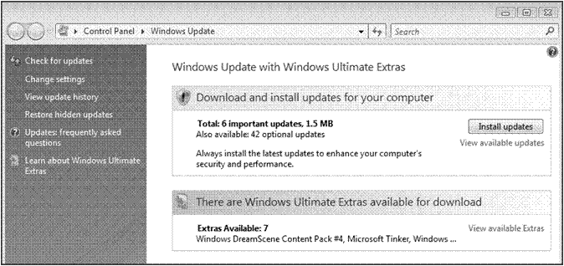

Windows Vista Extras dialog box

1. 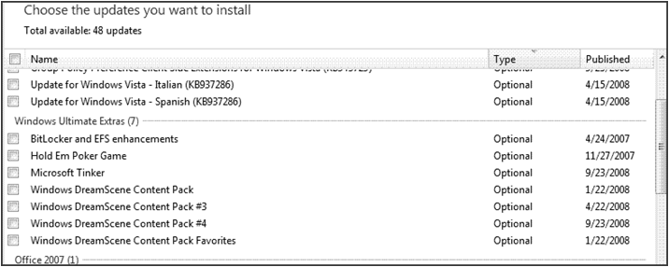In the section, There are Windows Ultimate Extras available for download, click View available Extras.

Updates/Extras Installation Selection

Take a moment to review the choices available as Vista Ultimate Extras. For example, each user can choose a **preferred language** that will appear when he/she logs on. If you are learning a language, you can easily switch back and forth between several language options.

Vista Ultimate also makes it **easy to find files**, documents, or images on your computer, and makes Internet search more streamlined with the Windows Vista Search tool.

Explore: Communicate with images using the Snipping Tool®

One of the handiest tools available with Windows Vista is the **Snipping Tool**, which enables you to capture and save images from the Internet, Word® document, Excel® spreadsheet, or other document displayed on your computer screen. Images are then saved as JPEG or GIF files (picture files) or as an HTML file (a web-compatible file format).

1. Open your Internet browser. Go to <http://www.pa.msu.edu/abrams/AstronomyClub/comet.gif>
2. Click StartMenuButtonand then select Snipping Tool. The following dialog box will open on your screen.

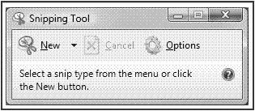

Snipping Tool dialog box

1. Click the arrow to the right of **New** and select Free-form Snip. A pair of scissors will appear instead of the cursor.
2. Place the scissors close to the image of the comet. Left click and drag the scissors around the image. When you release the mouse button, the image will appear in a new window.
3. Click File and then Save as. Type Comet in the **File name:** box. **Save as type:** JPEG file and click Save. Save to the pictures folder. Close any open files.

Explore: Setting Up a Project Workspace using MS Office Live®

Mrs. Reddington has assigned each member of your class to a subject-area team and each team is getting ready to plan project activities and assign work tasks. Your team decides that its first task should be to create a shared workspace using MS Office Live Workspace.

1. Open the MS Office Live sign-up page at <http://www.officelive.com/> . Click Get a FREE Workspace.
2. On the next page, you will be asked to type in your e-mail address. This should be an e-mail address that you can easily access from here.
3. You will next be prompted for a password and other information. Type the requested information. You will be able to access and use this Office Live workspace after this session.
4. After completion of the sign-up procedures, you will either see a screen similar to the one below, or a different screen that directs you to create a workspace.

**Note**: If you do not have access to e-mail during this session, your instructor will provide you with a url to access the MS Office Live Site.

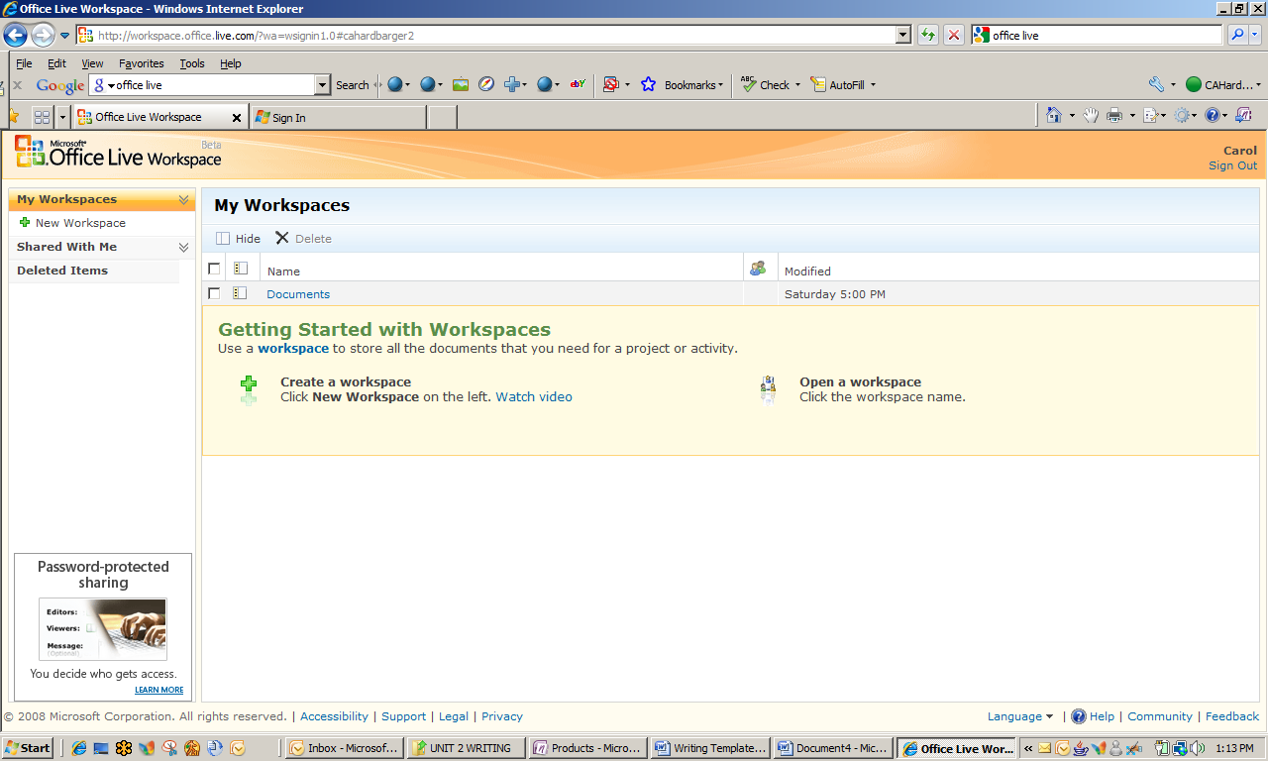

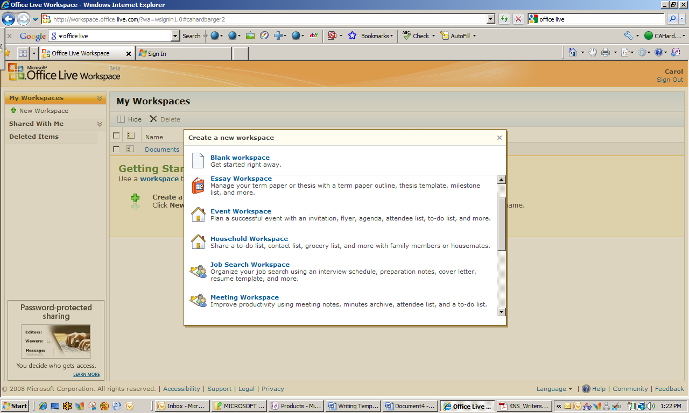MS Office Live Workspace

1. Click New Workspace in the left side navigation pane. You will see a screen similar to the one at right.

Creating a New Workspace: Selection Menu

Scroll to and select Project Workspace in the **Create a new workspace** dialog box. A workspace will be created for you.

1. Note that there is a highlighted space in the bar at the top of the workspace, with directions for you to type a description (name) for this new workspace. Type [Your Name] Newsletter Project in the highlighted area and click anywhere outside the box to save the title.

Your project workspace will resemble the screen below.

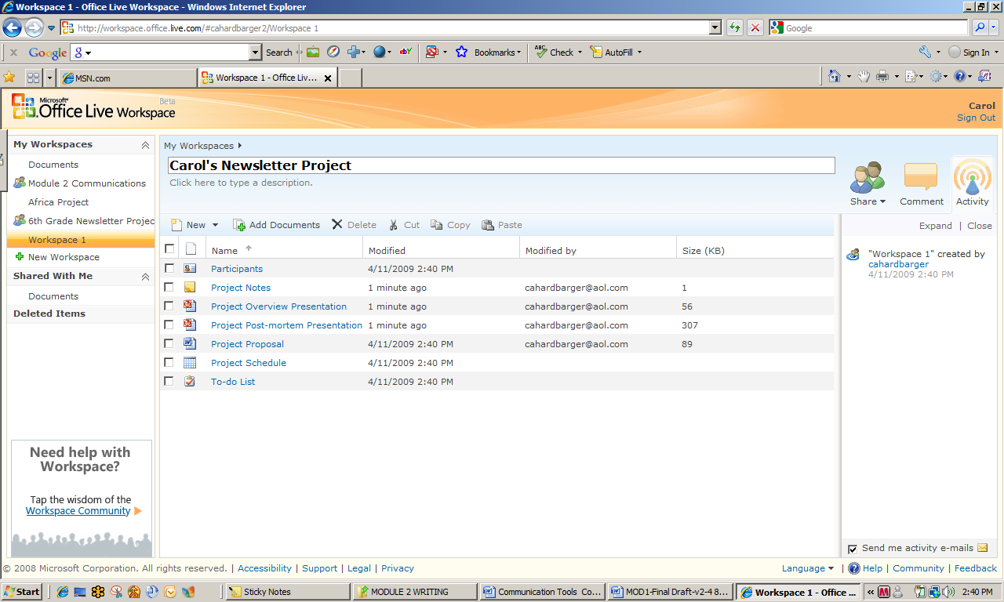 Project Workspace Templates

1. Click Add Documents. Upload the document, *History of Flight Timeline*, to your workspace. Find the document *Interview with Former Astronaut* and also upload it to the workspace.
2. Note all the other features that the project workspace template provides for you and your students. Click at least three of the document types (e.g. Participants) and view their contents.
3. Leave the Office Live workspace open.

Explore: Sharing Your Workspace and Documents with Team Members

You have just finished creating your Office Live workspace and uploaded two documents to it. Now you are ready to share access to your workspace and some documents with other team members. They will also be sharing their workspaces and documents with you. Once that happens, you will be able to access each other’s documents on the Office Live Project workspace, review and edit, and save documents as separate versions.

1. If necessary, login and access your Office Live project workspace. To access the workspace, click [Your] Newsletter Project in the left-side navigation pane.
2. In order for team members to share your workspace, they must be invited to do so. Click the arrow below the **Share** icon in the upper right of your workspace. Select Share Workspace.
3. In the Editors: box, type the e-mail addresses of two people sitting close to you. Click Send.
4. Sharing a document involves a few more steps. From your workspace, select the document *Interview with Former Astronaut* and then click Copy.
5. Open the documents workspace by clicking Documents under **My Workspaces** in the left navigation bar.
6. Click Paste. Your document should appear in the documents list. Select your document from the check box in the left column. Click Share and then click Document from the pull-down menu.
7. Type your team members’ e-mail addresses (those persons with whom you shared your workspace) in the Editors: bar.
8. Click Send in the lower right area of the screen. An e-mail message will be sent to your team members with a link to connect to your workspace. You will also receive an e-mail with a link to connect to your team members’ workspaces.
9. Follow any instructions in the e-mail messages that you receive.

Accessing a Shared Document

1. If necessary, open your Office Live project workspace. Under the heading, **Shared With Me** in the left navigation pane, click Documents and then select one your team members’ shared documents.

Test Your Knowledge

The tasks below were addressed in this unit. Be sure you understand the terms used and are able to complete the tasks listed.

Review Me – Project Based Learning

1. Develop a working definition of Project Based Learning. \_\_\_\_\_\_\_\_\_\_\_\_\_\_\_\_\_\_\_\_\_\_\_\_\_\_\_\_\_\_\_
2. \_\_\_\_\_\_\_\_\_\_\_\_\_\_\_\_\_\_\_\_\_\_\_\_\_\_\_\_\_\_\_\_\_\_\_\_\_\_\_\_\_\_\_\_\_\_\_\_\_\_\_\_\_\_\_\_\_\_\_\_\_\_\_\_\_\_\_\_\_\_\_\_\_\_\_\_\_\_
3. How important do you think effective communications are to successful Project Based Learning? Explain your answer.
4. \_\_\_\_\_\_\_\_\_\_\_\_\_\_\_\_\_\_\_\_\_\_\_\_\_\_\_\_\_\_\_\_\_\_\_\_\_\_\_\_\_\_\_\_\_\_\_\_\_\_\_\_\_\_\_\_\_\_\_\_\_\_\_\_\_\_\_\_\_\_\_\_\_\_\_\_\_\_
5. \_\_\_\_\_\_\_\_\_\_\_\_\_\_\_\_\_\_\_\_\_\_\_\_\_\_\_\_\_\_\_\_\_\_\_\_\_\_\_\_\_\_\_\_\_\_\_\_\_\_\_\_\_\_\_\_\_\_\_\_\_\_\_\_\_\_\_\_\_\_\_\_\_\_\_\_\_\_

Review Me – Vista Ultimate Extras

1. Locate the Windows Ultimate Extras menu option.
2. View available Ultimate Extras and make selections.

Review Me – Snipping Tool

1. If necessary, open your Internet browser and log into your Office Live workspace. Locate the Snipping Tool.
2. Do a rectangular snip that includes the documents in your workspace. Use the Snipping Tool to capture an image on your screen.
3. Click the Highlighter icon and highlight the names of any two documents on your captured image.
4. Name and Save the image as a JPEG file.

Review Me – Office Live Workspace®

1. Share your workspace with at least one additional person as an editor and one person as a viewer.
2. Add the document, *Diameter of the Moon*, to your workspace.
3. Share the document, *Diameter of the Moon,* with at least one person and send him/her an invitation to view the document.

Curriculum Connections

Students use computers in the classroom as a tool for both productivity and learning. Integrating computer skills with the academic curriculum motivates and engages students, and prepares them for the technology age.

Below are a few ideas which can be used to integrate the skills covered in this unit into the academic curriculum.

Idea 1 – Use the Snipping Tool to Enhance Reports and Presentations

* Art students capture images of pre-Columbian era art, save, print, and add to a collage that will be used as part of a history poster project.
* Math and science students capture web-based charts and graphs that illustrate research results.
* Language arts students capture images and use them to illustrate an original poetry book.

Idea 2 – Using an Office Live Workspace

* Interdisciplinary teams collaborate on project planning, task assignment, and timeline.
* All of the 6th grade students work on organizing a book fair. Various teams use Office Live Workspace to manage various logistics.
* Teachers use Office Live Workspace to plan and organize the science fair.
* Sports teams and other school clubs post and manage schedules.

Use the space below to write down additional curriculum connections ideas:

|  |
| --- |
|  |
|  |
|  |
|  |
|  |
|  |
|  |
|  |
|  |
|  |
|  |
|  |
|  |
|  |
|  |
|  |
|  |
|  |
|  |
|  |

Unit 2: Brainstorm, Capture and Organize

Unit Objectives

Create a digital notebook and notebook sections using MS Office One Note 2007.

Add documents, images, screen clips, and sounds to One Note notebook sections.

Brainstorm, Capture and Organize

All the project teams in your classroom have become excited about the projects and their assigned tasks. Everyone is busy gathering information and trying to keep track of it. Unlike the past, the 21st Century student has tools available to make both collecting and organizing information much easier.

Think for a moment about what steps are involved in effective communications:

* Developing ideas.
* Capturing and collecting information you plan to share.
* Organizing information in a way that allows for retrieval and review.

You and your team members are going to work through these steps, using a tool that was specifically designed for that purpose—MS Office One Note 2007®.

Working with MS Office One Note 2007

OneNote is an idea processor, a notebook, an information organizer — some even call it an "add-on pack for your brain." OneNote can help if you need to:

* Organize scraps of information that do not fit well into e-mail, calendar, or formal documents.
* Gather and refer back to notes from meetings or lectures.
* Collect research from the Web or other sources and annotate it for yourself or others.
* Keep track of what you need to do next and not miss anything.
* Work closely with other people on a project sharing notes and files.

OneNote will complement most of the tasks you perform in Word, MS Outlook®, or other MS Office® through several important integration features. You can quickly **capture meeting notes**, brainstorming notes, ideas and thoughts, audio from discussions, video from interviews, diagrams, and other pieces of information using the keyboard, pen or recording capabilities in OneNote.

**Gather clippings from the Web**, e-mail, miscellaneous materials for projects, customers, and classes, files, pictures, and other purposes using convenient integration with your Web browser and the Office system. With OneNote, all this **information stays in one place**. It is easy to organize it, or pile it together (if that’s your preference), and then search and find it again — even words in pictures and audio or video recordings! Since OneNote uses the familiar concept of notebooks divided into sections with pages, you can get going right away.

Research Findings on One Note and Learning Styles

Dr. Ole Lauridsen, from the University of Aarhus in Denmark, conducted research on OneNote and Learning Styles. His work describes how the flexibility of OneNote 2007 allows for different learning styles among students—emotional, sociological, sensory, analytic, and global— as summarized in the following table. .

Table 1: Support of MS One Note 2007 for Varied Learning Style Needs

|  |  |  |
| --- | --- | --- |
| **Learning Style** | **Definition** | **Suggestions** |
| **Global** | Learn by absorbing material in random order without necessarily seeing any connections until they have grasped the whole concept. | OneNote 2007 is ideal for the global learner. Provide a notebook with sections and pages on a specific topic and let the learner select the order they want to navigate and learn the information. |
| **Analytical** | Very detail-oriented and  remember specific facts about things. | In OneNote, you can have either pages or a section with all the pertinent facts on a specific topic. You can also include links where the analytical learner can get additional facts. |
| **Social** | Learn by interaction with other people. They need one on one attention. | Using the collaboration tools in OneNote 2007 social learners will find learning fun and easy. |
| **Kinesthetic** | Need to make physical contact with things that they are learning about. | For the kinesthetic learner, you can use OneNote 2007 to create interactive activities, learning games, or instructions for how to build something. |
| **Auditory** | Learn best by hearing things, either on tape or in a discussion. | When using OneNote 2007, it is easy to insert audio clips for the auditory learners. |
| **Visual** | Receive information best through their eyes and what they see and read. Many times this student will teach themselves to read. They often prefer color illustrations and materials that have charts and graphs inside them. | Using OneNote 2007, you can insert video clips for the visual learners. |

Source: http://www.learningstyles.net/

Brainstorm, Collect and Organize

Most of us are familiar with **brainstorming**—jotting down ideas on a piece of notebook paper or even a piece of scrap paper, only to have them lost soon thereafter! The use of a word processor such as Word to capture brainstormed ideas can solve part of that problem, but the saved document can wind up as another piece of paper in a locker or book bag.

Of all the options available to you and your team members as you work on your project, One Note may be the most versatile! Think of it as a **digital 3-ring binder**. Once created, you can gather various items, notes, and artifacts from a variety of sources for the articles that will be included in the finished project. One Note tools also enable you to **organize everything** you collect in such a way that you can easily find things by conducting a simple search of the notebook.

OneNote is a place for **gathering, organizing, searching**, and **sharing** notes, clippings, and reference material, even audio and video files. All your notes will be visible here — organized by notebooks, sections, and pages.

Explore: Creating a Notebook in MS Office One Note 2007

Team members are working to compile data. They are doing Internet and library research, conducting a few short interviews, and need a place to keep everything together. MS Office Live workspace has enough space for storage of their draft documents, but they need something beyond document storage and retrieval.

1. Click the Start button and select Office One Note 2007. If it is not listed on the start menu, click All Programs, Microsoft Office, and then select Office One Note 2007. You may also type One Note in the search box.
2. Find the **New** tab in the upper left corner of the notebook. Using the arrow to the right, click and select Notebook from the drop down menu. The **New Notebook Wizard** will appear.
3. Title the new notebook, e-Newsletter Project, and select Shared Notebook – Group Project from the **Template:** menu.
4. On the next wizard dialog box, select Multiple people will share the notebook and then On a Server. Click Next.
5. Click Browse to the right of the **Path:** box to access the **One Note Notebooks** folder. Click Select in the lower right corner of the dialog box.

Make certain that the box is checked to create an e-mail inviting team members to access the notebook.

Click Create to confirm the location of your stored One Note notebook.

An e-mail should appear with instructions to open the notebook. Send the e-mail to your team members. Leave OneNote open.

Explore: Creating Notebook Sections

Your team has decided to create different sections for the project notebook based on the stories that will be included.

1. If necessary, open One Note. Click File, New and then Section from the drop down menus.
2. Repeat Step 2 until you have a total of five (5) sections.
3. You now want to rename each section by subject area. Right click on the first section name and select Rename from the menu. Type Social Studies as the new section name.
4. Rename the rest of the project sections: Science, Math, Language Arts, and Audio-Video.
5. Leave One Note open.

Adding Documents and Other Items to One Note

There are several ways that you can add documents and other items to one note. When you are reading an important e-mail, for instance, you can “send it to One Note” and it will appear in a section titled **Unfiled Notes**. Any document created in Excel, PowerPoint or Word can sent to One Note using the Print command. You can also create a link to a file stored on your hard drive.

1. If necessary, open MS Office One Note. Open the document *Interview with an Astronaut* located in the Student Files.
2. Copy the document by typing Ctrl A, then Ctrl C.
3. Open the **Language Arts** section of your notebook. Place the cursor anywhere on the page and type Ctrl V. The document will be pasted into the notebook.

**Note**: You may have to erase a text box or other images from the original notebook page.

1. Open the **Math** section of your notebook. Place the cursor anywhere on the page. Click Insert and then Hyperlink from the drop down menu.
2. In the Text to display: box (lower box), type Link to Science article. Click Browse for File beside the file address box.
3. Locate your student files and select the document, Diameter of the Moon. Click OK. A link to the document, *Diameter of the Moon*, is now on a page in the Science section of your notebook.
4. Return to the Office Live Workspace shared for this project. Click on the document History of Flight Timeline to open it. Type Ctrl A and then Ctrl C to copy the document.
5. Open the **Social Studies** section of your One Note notebook. Place the cursor anywhere on the page and type Ctrl V. The document should now be pasted to the notebook section.

Adding Typed Text

One Note is so flexible! You can make notes with a Tablet PC pen or you can type them as well!

1. Add suggested titles for each of the articles. Open the Science section and place the cursor anywhere at the top of the page. Type Science Project Title: Science Class Has Gas!
2. Add a typed title to the history and math articles. Leave your notebook open.

Explore: Insert and Customize Tags in your notebook

Sometimes you want or need to identify important items in your notebook. Just as in a regular 3-ring binder, One Note has “tags” that allow you to mark the important materials, notes, concepts, or things to do.

1. Click Insert and then Tag to show the following drop down menu.

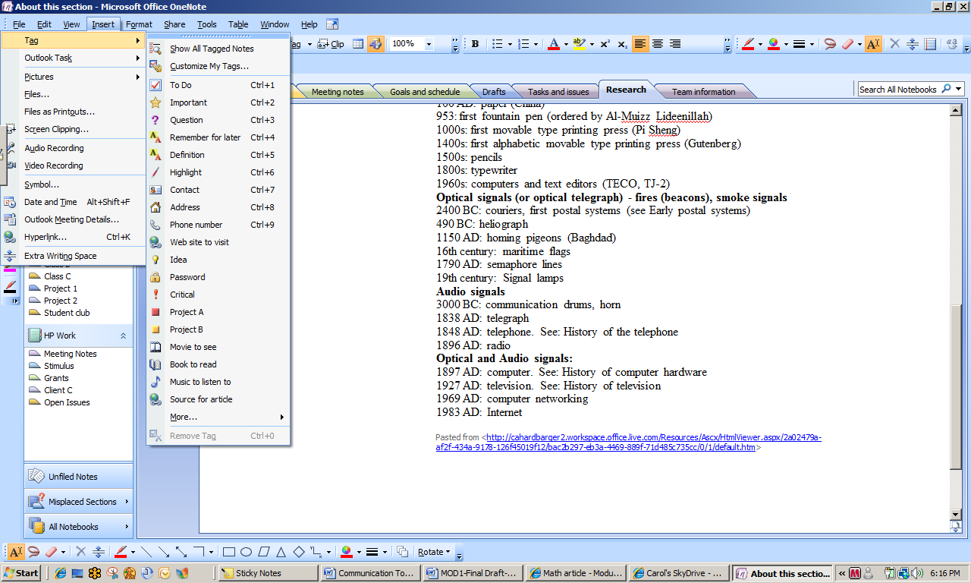

Tag Selection Menu

1. Open the **Social Studies** section of your notebook and place the cursor on any line of text. Click Insert, Tag, and then select Important. A star will appear to the left of the text in your document.

You can customize tags to make them relevant to your content or materials. For example, if you use OneNote 2007 at work, you can create a set of tags that support your job duties. Similarly, students can create tags that are associated with specific tasks or concepts learned during class. The image below illustrates a set of customized tags for your lesson plans.

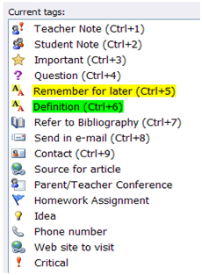

1. Click Insert, Tag, and then select Customize My Tags. A **Customize My Tags** pane containing all the current tags opens to the right of your notebook page.
2. Scroll through the tags to find and click Discuss with Person <A> and then click Modify. The **Modify Tag** dialog box appears.
3. In the **Display name**: box Type Discuss with Mrs. Reddington.
4. Change the symbol, font color, and highlight color.
5. Click OK to save your changes.

To save time you can look at all the tagged notes at once.

1. Click View and select All Tagged Notes from the drop down menu. A **Tags Summary** pane appears to the right of your notebook page.
2. Leave your notebook open, but close all other open files.

Explore: Incorporating Audio Files into Your Notebook

Your project is beginning to look organized! You have created a shared workspace using Office Live and a notebook for storing all project documents, images, notes, and other things. However, you don’t have to worry about carrying highlighters, sticky note pads, paper clips, or other office supplies around because One Note has all those tools available in digital form.

Another tool provided by One Note is the ability to insert images and audio files into your notebook. This further enhances your capabilities to make good decisions when creating mockups or putting finishing touches on the final product.

1. If necessary, open your One Note notebook and go to the **Math** section. Place the cursor anywhere on the page. Click Insert, Pictures, and then From Files.
2. Locate the image Full Moon in your student files and select. Click Insert. The image will appear on your notebook page. Place the cursor anywhere close to the image and type The Earth’s Moon as a caption.

Explore: Incorporate Screenshots into Your Notebook

Students in the 21st Century are Internet savvy and most have learned to do research on the web. The Internet has also become a primary source of news for many adults, old and young alike. Whatever the task, research, preparing lesson plans, or just information gathering, One Note tools enable you to capture screenshots to store and use at a later time.

1. There are several ways to capture **screenshots** of what you see on the Web or in other programs. Open your Internet browser. Go to <http://galileo.rice.edu/bio/narrative_1.html>.
2. A short narrative on the early life of Galileo appears.
3. Type the Window Logo Key C:\Users\jpond\AppData\Local\Temp\msohtmlclip1\01\clip_image001.png , then S. The cursor becomes a crosshair and you will be directed to draw a rectangle around the image you wish to save.
4. Draw completely around the image of the lakes. It is automatically saved to the **Unfiled Notes** section of One Note. Notice that a bubble appears in the lower right corner of the screen to notify you that the image has been saved.
5. You can also place an image into a specific document or section instead of the Unfiled Notes. Go to <http://history.msfc.nasa.gov/vonbraun/bio.html>, which is picture and biography of Dr. Wernher von Braun.
6. Go to the **Science** section of your notebook. Place the cursor anywhere on the page. Click Insert and then select Screen Clipping from the drop down menu. Leave your notebook open.

Customizing Screen Clips for One Note

You can customize options for screen clippings by right-clicking the OneNote icon in the Windows taskbar: C:\Users\jpond\AppData\Local\Temp\msohtmlclip1\01\clip_image004.png

1. Right click the One Note icon in the Windows task bar. Click Options then Screen Clipping Defaults. You can select whether you want to

* Copy to Clipboard Only (for a later paste to a document).
* Copy to Clipboard and Unfiled Notes (Show image)
* Copy to Clipboard and Unfiled Notes (Don’t show image)

1. Leave as is.

Test Your Knowledge

The tasks below were addressed in this unit. Be sure you understand the terms used and are able to complete the tasks listed.

Review Me – Creating a new Notebook

1. Create a new notebook titled [Your Name’s] 4-H Projects in One Note 2007.
2. Rename two sections: Space, and Garden
3. Type a few comments in each section.

Review Me – Adding content to your Notebook

* 1. Open the file, *What is Thrust?* Copy and Paste into the **Science** section of your One Note notebook.
  2. Go to <http://teachertech.rice.edu/Participants/louviere/Newton/newton.html> and insert a screen clipping into the Language Arts section of your notebook.
  3. Create a hyperlink to the picture, *Goddard’s First Rocket*, and add it to a page in the Social Studies section of your notebook.
  4. Type a comment, this might be useful for the English article.
  5. Locate a sound file in your Student Files and copy it to your notebook, any section or page.

Curriculum Connections

Students use computers in the classroom as a tool for both productivity and learning. Integrating computer skills with the academic curriculum motivates and engages students, and prepares them for the technology age.

Below are a few ideas which can be used to integrate the skills covered in this unit into the academic curriculum.

Idea 1 – Use One Note to Facilitate Completion of Tasks

* Language arts students create bibliographies and resource notes while writing their reports.
* Biology students save related web site links while researching photosynthesis.
* The Economics teacher stores images and PowerPoint files for use at a later time.
* Homework assignments are downloaded, completed, stored, and submitted using One Note.
* Built in templates make it easy to create a schedule.

Idea 2 – Build e-portfolio for a Class and/or an Individual Student

* Keep completed homework assignments in one place.
* Store all group or individual completed projects in one notebook.
* Add notes on progress and recommendations for continuing study.
* Students can record their own observations of a lab experiment, drawing illustrations of the apparatus used, compounds formed, etc.

Idea 3 – Support auditory and visual learning styles

* Use audio capture to emphasize topic of study with analogies.
* Provide images that match subject content and create “Match picture to subject” quiz.
* Use audio files to encourage students to “speak their minds” on study topics. Learn to communicate more effectively and practice proper pronunciation.

Use the space below to write down additional curriculum connections ideas:

|  |
| --- |
|  |
|  |
|  |
|  |
|  |
|  |
|  |
|  |
|  |
|  |
|  |
|  |
|  |
|  |
|  |
|  |
|  |
|  |
|  |
|  |

Unit 3: Using MS Office Templates

Unit Objectives

Create a To-do list using MS Office Word templates.

Use a Microsoft Excel template to build a timeline.

Enhance a presentation using an MS Office PowerPoint template.

Using MS Office Templates

Your team has collected an organized a lot of information, and stored it in One Note and on your Office Live project workspace. Many ideas have been generated, pictures identified, and you are ready to start putting some of the information together in a draft form.

The MS Office Tools have many templates available to help you get started. There is no need to waste time on design and style when Office can help with those tasks!

* **MS Office Word 2007** provides access to thousands of templates for any document you may create using a word processor: calendars, notes and memos, to-do lists, reports, resumes, and many others.
* **MS Office Excel 2007** provides many of the same templates as Word, with several items unique to spreadsheet or database use: invoices, inventories, purchase orders, receipts, and others.
* **MS Office PowerPoint 2007** allows the user to incorporate color, font, and other design features to ensure a presentation is attractive and engaging. Presentations can be designed for academic or business audiences, to present floor plans and other diagrams, and to create achievement awards.
* **MS Office One Note 2007** provides access to templates that make the organization of information much easier. For example, the academic notes templates contain sections for placement of important objectives, an outline of lecture notes, and notations for homework or other assignments.

Accessing and Using MS Word Templates

The Math group hasn’t been as organized as others so they feel they need to work on a to-do list. This will help them keep track of all the activities they have to complete to write their article on the moon and calculating the diameter of the moon.

1. Open MS Word. Click the Start button and select MS Office Word 2007. If it is not listed in the Start menu, click All Programs, then Microsoft Office. Select MS Office Word 2007. You can also type Word in the Search box.
2. Click the Office button and then New. You will see a **New Document** dialog box.
3. Scroll through the **Templates** list on the left and select Lists. Select Home from your choices of lists.
4. Scroll through the lists options and select Simple Checklist. Click Download. The list template will appear as a new document as in the illustration below.

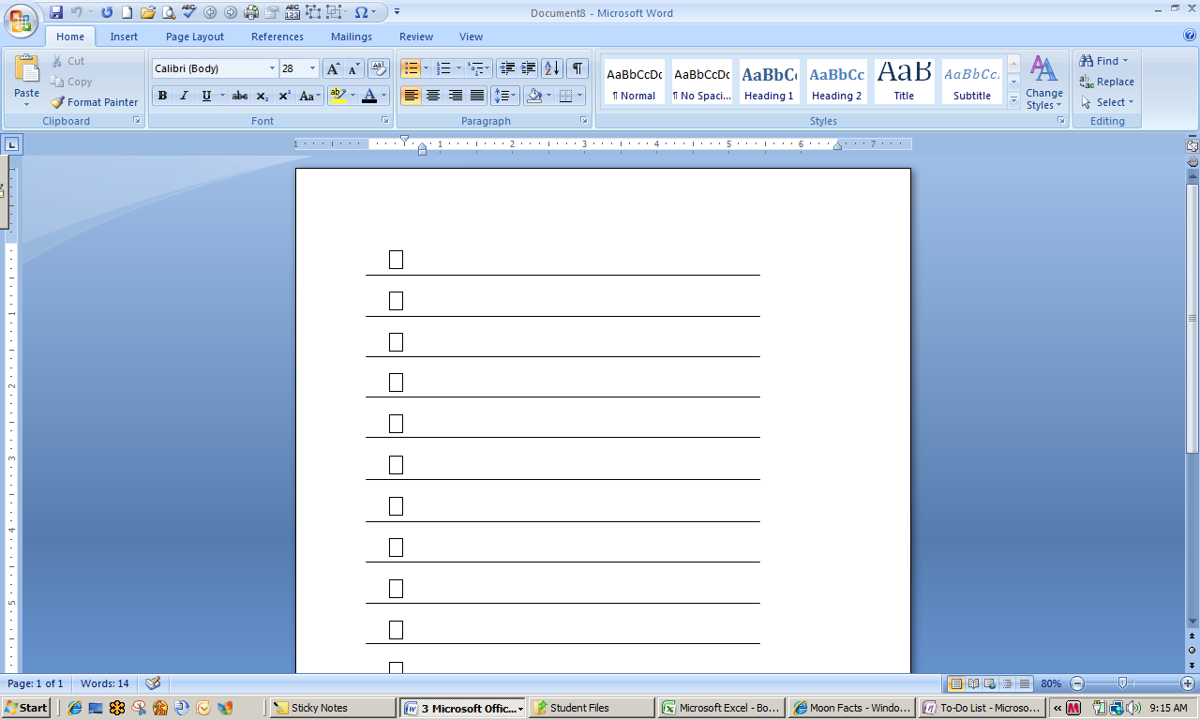

MS Word Simple Checklist Template

1. Type the following items in your to-do list.

Add lab activity on moon diameter to notebook

Complete lab activity and record results

Write a first draft of article from Moon Facts

Add information about website for readers to calculate their weight on the moon

Share first draft with team members for review

Create final draft to include in newsletter

1. Create a new page in the Math section of your notebook called To-Do List by using the Print function of Word. Click the Office button, Print, and then select Send to One Note.2007. Click OK. The To-Do List is added to the Unfiled Notes in your notebook.
2. You can now check off activities as they are completed using the Tablet Pen or by typing.

Using Excel to Visually Communicate a Timeline

A timeline can be used **to represent chronology** from many different curriculum areas, such as science, social studies, mathematics, and language arts. Timelines often show changes over time in areas such as transportation, technology, space travel, and so on. They also work well when representing people's lives (for example, the life of a student, a character from a story, or a famous person) and events throughout history.

Using a MS Office Excel 2007 spreadsheet makes creating an accurate and attractive timeline both easy and fun. You can designate periods of time by utilizing fill colors to fill in groups of cells. Text can even be entered sideways to mark the events being represented. If students are feeling creative, they can enter text inside a drawing, such as a rectangle, or add pictures to enhance the timeline. Younger students might use pictures instead of words to represent events on their timelines. Below are two sample timelines for more ideas. Both have been made using a regular Excel spreadsheet. You will be creating a timeline using an Excel template.

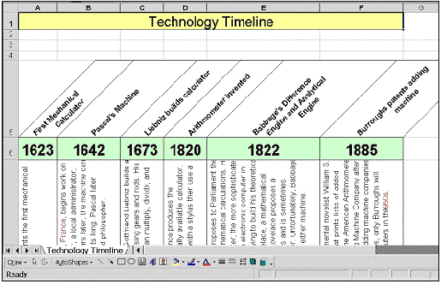

Technology Timeline

Notice that the Technology Timeline features rotated text within cells, borders around the cells, and cell fill colors. Each of these format changes is easy to facilitate using Excel tools.

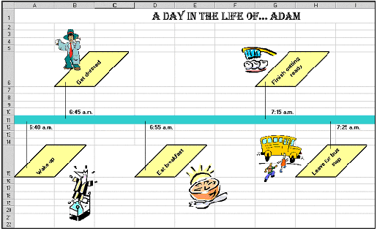

Personal Timeline

The Personal Timeline features rotated text within cells, cell fill colors, and clip art to enhance the appearance. Also, lines attach an event with its time.

When you implement a classroom project, you may want to have students complete a timeline for completion of activities as their first task. Or, you could have teams determine if a timeline might enhance the presentation of facts for their content areas. They could do any necessary research and then sketch out the timeline on paper before creating it in Excel.

Explore: Build a History of Flight Timeline with Excel Templates

The social studies group has been tasked with developing **a timeline of flight travel** as part of their project activities. They begin by conducting Internet research, locating a Space Day Foundation site with all the information they need. They also notice that there are dates and information included in the timeline that might be useful to some of the other teams.

After further discussion, they decide that they will create three timelines: 1) the period 1300 to 1900, 2) the period 1901 to 1960, and 3) the period 1960 to the present.

1. Open Excel. Click the Start button and then Microsoft Office Excel 2007. If Excel does not appear in the **Start** menu, click All Programs, Microsoft Office, and then select Microsoft Office Excel 2007. You may also type Excel in the Search box.
2. Click the Office button and select New. In the **Templates** menu on the left side, scroll to find and select Schedules. Select Timeline. Click Download. A timeline template will appear as part of your worksheet.
3. Open the document, *History of Flight Timeline Spreadsheet*. Move the instruction box to the right of your worksheet. In the **Page Layout** tab, **Page Setup** section, click Size. Select Legal.
4. Triple click on Timeline Title and type History of Flight Timeline.
5. Following instructions in the instruction box change the dates on the timeline so that they start with 1300. Skip a date, deleting the box, and make the third box 1400 and so on. Note that on the example below, a box has been added for 1900.

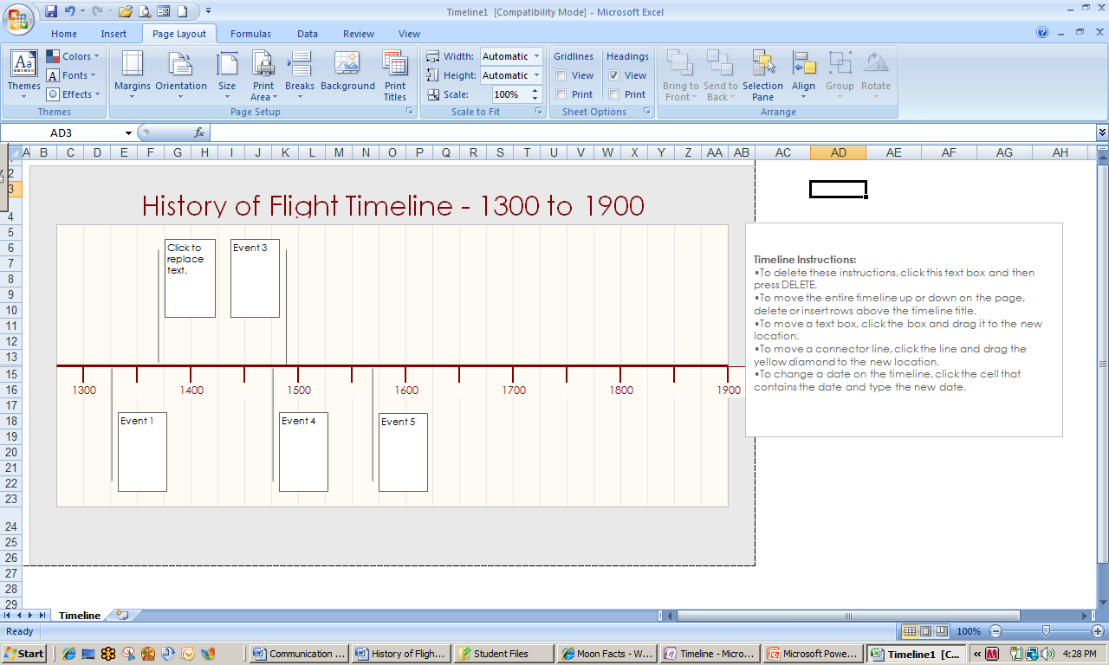

6

Excel Timeline Template

1. Following instructions, add the following information to the timeline, moving and resizing boxes as necessary.

|  |  |
| --- | --- |
|  | Event |
| 1300 | Marco Polo witnessed kites carrying humans in China |
| 1488 | Leonardo DaVinci made the first design of a flying machine in Italy. |
| June 4, 1783 | The Montgolfier brothers became the first to launch an unmanned hot air balloon. |
| September 19, 1783 | The Montgolfier brothers launched a second hot air balloon carrying a rooster, a duck, and a sheep. |
| December 1, 1783 | Jacques Charles launched the first success manned hot air balloon flight. |
| May 6, 1896 | Samuel Langley launches a steam-powered model aircraft over the Potomac River. |

1. Delete the instruction box by clicking the border until a solid line appears and then typing the Del key.
2. Your timeline can be sent to your notebook, printed, or added to a PowerPoint presentation.
3. Save your timeline as *[Your Name] Flight Timeline* close the file.

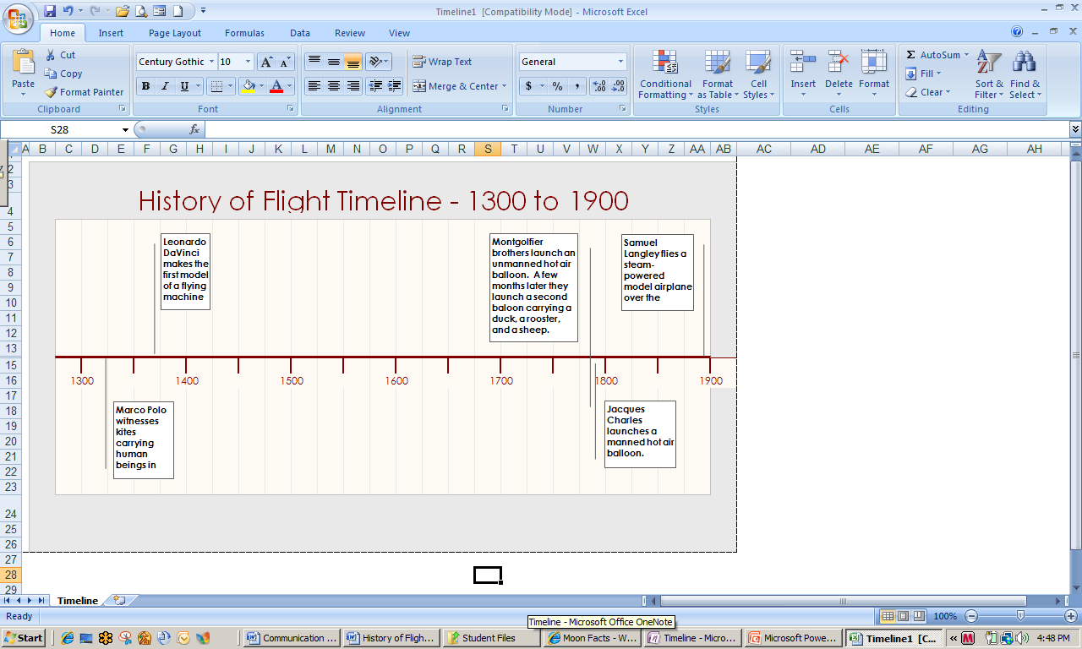 History of Flight Timeline Using Excel Templates

Creating a Presentation with MS PowerPoint Templates

MS Office Power Point 2007 enables users to create attractive and interest-catching presentations. In addition to participating in the newsletter publishing activities, the math team is planning to give a presentation to seniors at a local elder care facility on their project.

1. Open Power Point. Click the Start button, select Microsoft Office PowerPoint 2007. If Power Point is not on the **Start** menu, click All Programs, Microsoft Office, and then select Microsoft Office PowerPoint 2007. You can also access PowerPoint by typing Power Point in the **Search** box.
2. In the **Design** tab, **Themes** section, click the arrow at the lower right of the section. The team doesn’t like any of the available themes so decides to look at what is online. Select More Themes on Microsoft Office Online.
3. In the **Templates search box** at the top of the screen, type moon. Scroll to the bottom of the page and select Winter Moon by clicking on its name. At the next screen click Download.
4. Scroll through and read the Agreement and click Accept. Within a few seconds, the template will appear in your PowerPoint.
5. Save this theme to your collection by clicking the arrow to the right of the **Themes** section and select Save Current Theme. In the **File name**: box, type Winter Moon and then click Save.
6. Click anywhere in the title box and type The Moon. Type Facts and Figures in the subtitle box.

Making Formatting Changes

The text is too dark for the Winter Moon template so you will need to change it. Changing text color or other formatting options is easy in PowerPoint using the Master Slide.

1. In the **View** tab, **Presentation Views** section, click the Slide Master icon. Note that the various layout options are displayed in the pane to the left. Find the title master slide in the left pane and click to select.
2. Highlight Click to edit Master title style. This opens a **Drawing Tools** tab. Click Format in the **Drawing Tools** tab.
3. In the **Word Art Styles** section, click Text Fill. Select white text color. Do the same for the Master subtitle style section.
4. Move the text boxes show the text colors show up well on the dark background.
5. 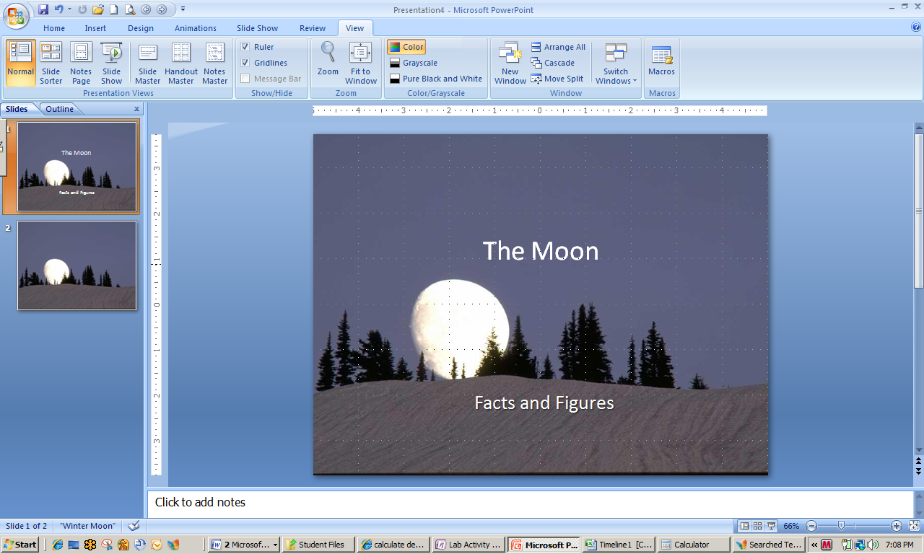Go to the **View** tab, **Presentation Views** section and click Normal to see the changes.
6. Go back to the slide master and change the font color on at least two other styles. Your title slide should resemble the one at the right.
7. Save as *[Your Name] Moon Facts and Figures*. Close the file.

PowerPoint Template with Changed Font Color

Using One Note Templates

Everyone has really been working! The science team is lucky because they have a 90-minute laboratory period once a week and the science teacher is allowing them to work on the Space Day project in science, as well. They are going to have a meeting to discuss how to proceed with their project activities.

1. Open your One Note notebook and go to the Science section. Click Format and then select Templates.
2. Open the **Business** options by clicking the + and then select Informal Meeting Notes. This template will immediately be added as a new page to the Science section.
3. Type Team Meeting in the **Meeting Title** box.
4. The rest of the page would be filled out using team meeting discussion.

Test Your Knowledge

The tasks below were addressed in this unit. Be sure you understand the terms used and are able to complete the tasks listed.

Review Me – Using Word Templates

1. Open MS Word. Open any To-do list template.
2. Personalize the list with information that might be useful for you.
3. Type 3-4 action items in the list.

Review Me – Using Excel Templates

1. Open MS Excel. Create multiplication tables from a template. Explore options for changing the format.
2. Download the family budget templates. Manipulate several of the numbers to see changes made by the built in formulas.

Review Me – Using PowerPoint Templates

1. Open MS PowerPoint. Change the presentation appearance by selecting one of the PowerPoint templates.
2. Explore options for changing the format.

Review Me – Using One Note Templates

1. Open One Note. Open the Science section. Create a prioritized To-do list from the Planners section of the templates. Type several items into each of the priority areas. Check several of them as completed.
2. In the Social Studies section, create Lecture Notes with Study Questions from the Academic section of the templates.

Curriculum Connections

Students use computers in the classroom as a tool for both productivity and learning. Integrating computer skills with the academic curriculum motivates and engages students, and prepares them for the technology age.

Below are a few ideas which can be used to integrate the skills covered in this unit into the academic curriculum.

Idea 1 – Using Word Templates

* Culinary Arts students use a Word recipe card template to store class recipes.
* The Future Teachers of America uses a Word agenda template to develop the agenda for each monthly meeting.
* Language Arts students use various greeting card templates to publish and distribute their poetry.

Idea 2 – Using Excel Templates

* The Science Club sells bedding plants in the spring and uses an Excel receipt template to create receipts.
* The Computer Lab monitor employs a student helper and uses an Excel timesheet template to keep track of the students’ hours at work.
* The head of the Math Department uses an Excel budget template to keep track of departmental finances.

Idea 3 – Using One Note and PowerPoint Templates

* History project team members create a to-do list, with priorities, using a One Note list template.
* A chemistry student uses a One Note academic template to create an easy-to-use lecture note format.
* The algebra teacher uses a PowerPoint template to provide an attractive design to a presentation to the school board.
* Students in history class use a PowerPoint template to create a presentation with a content-related theme.

Use the space below to write down additional curriculum connections ideas:

|  |
| --- |
|  |
|  |
|  |
|  |
|  |
|  |
|  |
|  |
|  |
|  |
|  |
|  |
|  |
|  |
|  |
|  |
|  |
|  |
|  |
|  |

Unit 4: Communicating with MS Learning Essentials

Unit Objectives

Create a project using MS Learning Essentials.

Use templates to create and share documents in Learning Essentials.

MS Learning Essentials

Learning Essentials transforms familiar Office applications into customized tools for 21st Century teaching and learning. It provides education-specific tools for students and educators to get the most out of their familiar Microsoft Office applications.

Curriculum-based templates and toolbars for Microsoft Office Word, the Microsoft Office PowerPoint® presentation graphics program and Microsoft Office Excel® spreadsheet software help students and educators get started, stay organized and successfully complete high-quality work.

Learning Essentials 2.0 includes SCORM (Sharable Content Object Reference Model) tools for authoring additional content and e-learning resources, a smaller network-based installation and centralized server administration.

Overview: Tools for Teachers

Learning Essentials has been designed with teachers for teachers to help make best use of precious planning time, create top-quality learning experiences and speed through every-day administrative tasks. With more than 117 templates and 38 tutorials developed in collaboration with leading education publishers, Learning Essentials helps you get the most out of your Office applications.

* Save time on common administrative tasks with Templates for classroom handouts and presentations, grading rubrics, managing your classroom and more.
* Stop searching menus to find key Office functions. Use customized Toolbars to get right to bibliography tools, math symbols, and foreign language keys.

Implement new teaching strategies.

Tutorials from content partners have fresh ideas and tools for designing great projects, evaluating writing and deeper technology integration in instruction. Find teaching strategies and classroom activities for Language Arts, Math, Science and Social Studies.

Save time on common tasks.

Templates with Project Assistance help you quickly prepare classroom handouts, grading rubrics, assessments, worksheets and more. Project Assistance provides contextual guidance and coaching from leading education publishers on implementing best practices. The Create Test Wizard helps you design tests and quizzes without worrying about formatting.

Create your own content.

An integrated Content Development Kit with simple templates help teachers create their own materials for Learning Essentials.

SCORM tools

Sharable Content Object Reference Model (SCORM) content authoring standards allow seamless conversion of Microsoft Office and web documents into standards-based objects – reusable by any SCORM conformant learning management system. Enhanced functionality transforms teachers and trainers into interactive learning creators with a few simple mouse clicks.

The SCORM tools are a component of the comprehensive THESIS 3.0 e-learning solution from [HunterStone](http://www.hunterstone.com), a Microsoft Gold Partner and a leading provider of e-learning and IT Tools for Microsoft environments. SCORM Tools are available for English, French, German, Italian, Norwegian and Spanish language versions only.

Overview: Tools for Students

Sometimes the hardest part about completing a project is getting started. Learning Essentials provides assignment-specific guidance in Microsoft Office applications such as Microsoft Word, PowerPoint®, and Excel. With curriculum-based templates, tools, and tutorials, Learning Essentials helps with a variety of subjects and assignments, from history reports and essays to physics projects and chemistry labs.

Getting past the blank page

Easy-to-use and intuitive tools, templates, and tutorials help students get past formatting questions and to the core learning in their assignments. Developed in cooperation with distinguished academic publishers, Learning Essentials includes tips and tutorials for managing projects and creating high-quality reports, presentations, science projects, and other assignments.

Parlez vous francais?

Learning Essentials unlocks tools in Microsoft Office specially designed for foreign language study, providing templates for completing assignments in Spanish, French, and German. Language templates are automatically set to the specified language, giving students immediate access to diacritical marks, special characters and language-specific spell check and translation tools.

Putting together a polished package

Learning Essentials helps students create accurate and compelling work—even in challenging subjects like math and science. Guidelines and templates for Microsoft PowerPoint make for sharp analytical presentations and templates for Microsoft Excel improve critical thinking and data analysis. Microsoft Producer, the popular PowerPoint add-in synchronizes audio and video with text and graphic images to add life to recorded presentations.

Overview: Content from Publishers

Click through tutorials and side-by-side Project Assistance from leading educational publishers provide academic guidance for students and best practices for educators so they can do their best work. For example, the 28 student tutorials include The Writing Process, which helps students successfully complete the four basic stages of writing.

Using Manipulatives tutorial demonstrates best practices in the use of manipulatives in math instruction. More than 35 other tutorials address classroom management issues, using new assessment tools, and technology enhanced teaching strategies by subject area.

Overview: Create New Content

Learning Essentials for Microsoft Office is an open framework that enables education content developers – both educational publishers and educators – to create additional resources using simple XML-based authoring for deep integration with the world’s most-used classroom productivity suite.

Educational publishers can present their instructional content within the tools that students and teachers use every day to complete assignments and lessons. Educators can use these simple authoring tools to create their own educational modules, teaching resources or administrative templates.

Create your own Learning Essentials content.

The Content Development Kit is integrated with Learning Essentials for Microsoft Office 2.0 to enable educators, publishers and other content developers to create additional Learning Essentials templates and tutorials.

With the Learning Essentials CDK you can:

* Create new education templates for Word, PowerPoint and Excel.
* Link education-specific Office toolbars to your templates.
* Provide project assistance to provide step-by-step guidance for students or teachers.
* Create tutorials that provide academic instruction or professional development that incorporate the use of Microsoft Office tools.
* Link templates to your tutorials to help students or teachers to turn your strategies into action.

Source: Microsoft, Learning Essentials for Microsoft Office

[www.microsoft.com/learningessentials/ProductDetails.aspx?pid=001&active\_tab=Overview](http://www.microsoft.com/learningessentials/ProductDetails.aspx?pid=001&active_tab=Overview)

Using Learning Essentials to Communicate

Quality feedback is an important component in any learning situation, but it is especially important in the Project Based Learning environment. Because their work is constantly evolving, students need regular insights from the teacher on their progress, what is going well, and what could be possibly improved upon.

Explore: Create a Rubric Using Learning Essentials for Teachers

Your students have reached the first benchmark in their projects. Although you have been providing them with daily formative assessments, it is time to develop and distribute a summary of their progress to date. This summative assessment will be done with a rubric that will evaluate their individual and group process skills and also the skills they have developed setting up their project notebooks.

1. Open Learning Essentials for Teachers. Click the Start button, click All Programs, and select Learning Essentials.
2. Click Learning Essentials for Teachers. The following Welcome Screen will appear.

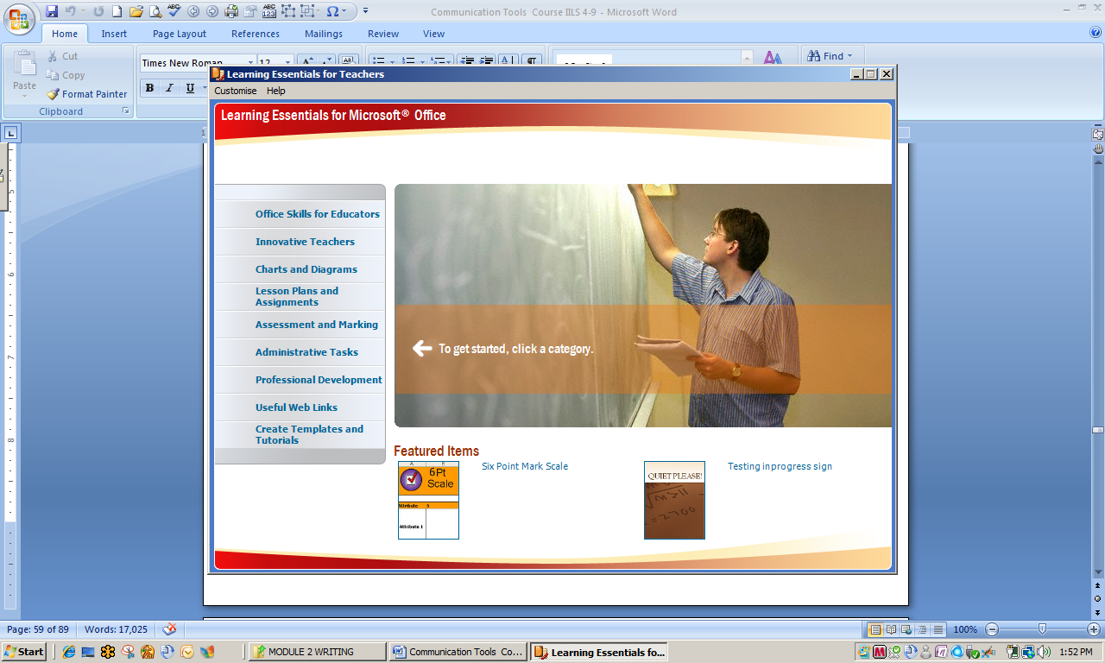

Learning Essentials for Teachers Welcome Screen

1. Select Assessment and Marking, then Rubrics. Select 5-Point Marking Scale.
2. Since this is a mid-point formative assessment, you can delete the last two criteria of the rubric. Highlight rows 9 and 10. Type the Del key to delete the rows.
3. Highlight row 6. In the **Home** tab, **Alignment** section, click Wrap Text. Add the following information to the rubric.

Course name: Reddington – Science Name: Susan Nelson

Criteria 1: Contributes to group goals

5 points: Consistently and actively works toward group goals; willingly accepts and fulfills individual role within group.

4 points: Works toward group goals without prompting; accepts and fulfills individual role within group.

3 points: Works toward group goals with occasional prompting; accepts individual role within group but may need prompting to fulfill it.

2 points: Will work toward group goals with occasional prompting.

1 point: Works toward group goals only when prompted.

1. Assign a grade of 4 points to Susan for Criterion 1.
2. Save as *[Your Name] Rubric.* Close the file.
3. Leave Learning Essentials open for the next activity.

Explore: Creating a Project

Learning Essentials enables teachers to create a Project Folder and project-specific templates for use by students. A Documents folder keeps project information together and easily accessible to students. Learning Essentials contains the types of resources that teachers can use to communicate expectations to students, provide timely feedback, and create opportunities individual students to work at their own pace.

1. If necessary, open Learning Essentials for Teachers. Choose Create Templates and Tutorials from the main menu. Select Creating Content for Learning Essentials and then click Content Development Kit.
2. Click Create a Project. Title the project, Space Day Project and make sure that Student is selected in the Content designed for: box. Learning Essentials automatically creates a document folder with files and folders that will be useful to any project.

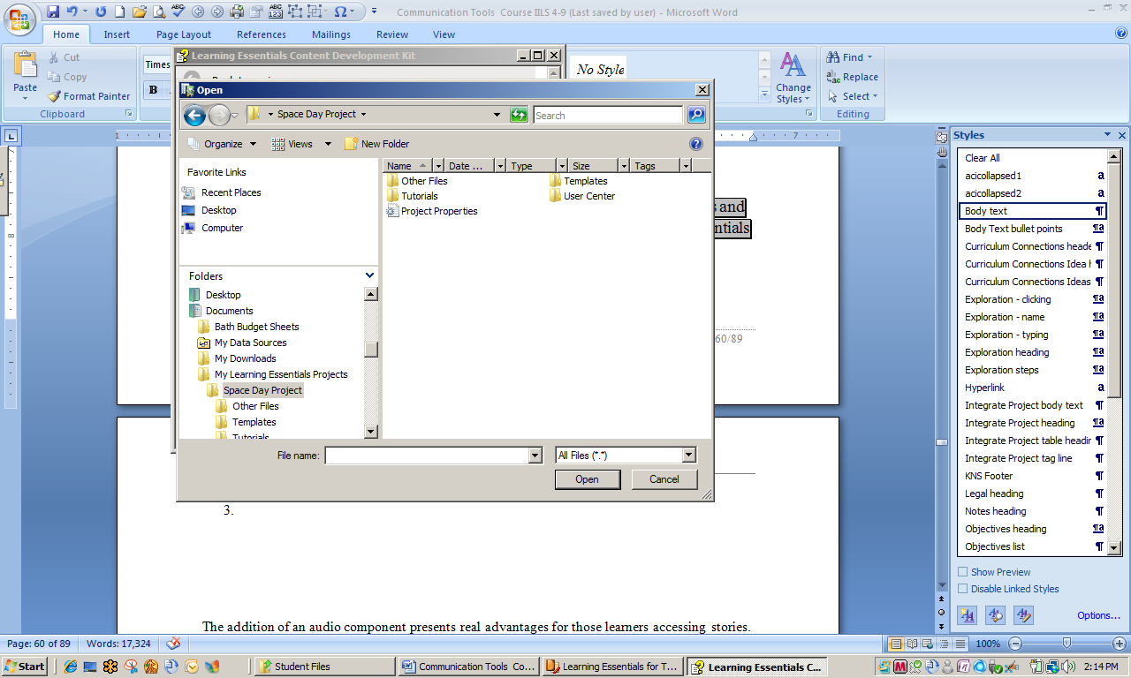

Learning Essentials Document Folders

1. Return to the Content Development Kit and select Add or edit content. Click on Create a Word Template. Title the template Report Checklist. A new word document is automatically opened.
2. Type the following information:

Report topic selected

Brainstorm ideas with team

Initial research conducted

Content outline developed

Freewriting first draft completed

Review and revisions

Second draft completed

Final draft completed

1. Highlight all, change font to 14, double-space, and then bullet the list. Change the bullets to check boxes.
2. Click the Office button and then Save As. Learning Essentials automatically saves the document to the Templates folder in the Space Day Project.

Learning Essentials for Students

Learning Essentials also has many useful tools for students. Once Mrs. Redding created the Project folder and provided instructions and templates for students to use, the teams are able to move forward with their project activities. Pretty soon the math team will be presenting information about the moon to the Senior Center, the whole class will present the project to the school board, and the language arts team will read biographies to the third graders.

The project will culminate with the e-newsletter, which will communicate the project activities and information to the broader school and general communities.

Explore: Using Learning Essentials Presentation Templates

The language arts team is excited about presenting the important people of space travel in the newsletter, to the third graders at Hilton Elementary, and as part of the overall class presentation to the school board. They plan to use a Learning Essential template to create a few slides.

1. Open Learning Essentials for Students. Click Start, click All Programs, and select Learning Essentials. Select Learning Essentials for Students.
2. In the main menu, select Presentations and then Invention. Click the Invention – Circles and Squares icon.
3. Learning Essentials opens an 8-slide PowerPoint template with instructions to complete, but you can also edit as you choose. Note also that a **Presentation Assistant** pane opens to the right of your presentation.
4. If the thumbnail pane is not showing on the left side, go to the **View** tab, **Presentation Views** section, and click Normal.
5. Change the title on slide 1 to Important People in Space Travel. Delete the Your Name/Your Class/Date text box by clicking the border until you see a solid line and then hitting the Del key..
6. Go to the next slide by clicking slide 2 in the left thumbnail pane. Change the layout to Two Content by going to the **Home** tab, **Slides** section, clicking Layout and then Two Content.
7. Change the title of slide 2 to Robert Goddard. Insert the picture *Goddard’s First Rocket* from the Student Files into the right text box.
8. Highlight the text in the left text box and change the font to 18. Locate and open the document *Robert Goddard bio* in the Student files.
9. Use the information from the bio to write a short paragraph in the left text box. Your finished slide should resemble the one below.

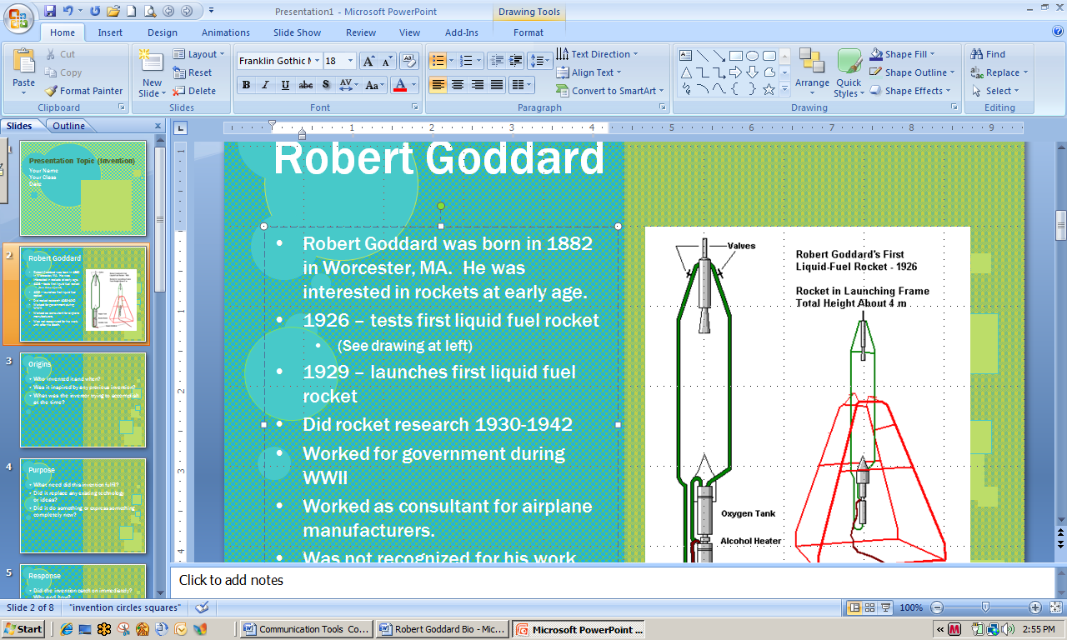 Learning Essentials PowerPoint Template

1. Save the file as *[Your Name] Space Bio Presentation.* Close the file. Leave Learning Essentials open for the next activity.

Explore: Using a Report Template

Mrs. Reddington has asked the math team to complete a formal lab report for the experiment they conducted on calculation of the diameter of the moon. Their notes and observations are recorded in One Note, but she wants a more formal report.

1. If necessary, Open Learning Essentials for Students. Open your One Note notebook, go to the math section and then the Lab Activity page.
2. Select Maths and Science from the Learning Essentials main menu. Select Lab Report and then Lab Report – Blank.
3. Toggle to open the lab report template. In the **View** tab, **Window** section, select Arrange All. The notebook lab activity and the report template should both appear on your screen so you can easily record information to the report template.
4. Use the information from Notebook to start completing the lab report. Your finished document should resemble the following: (formatted to single space)

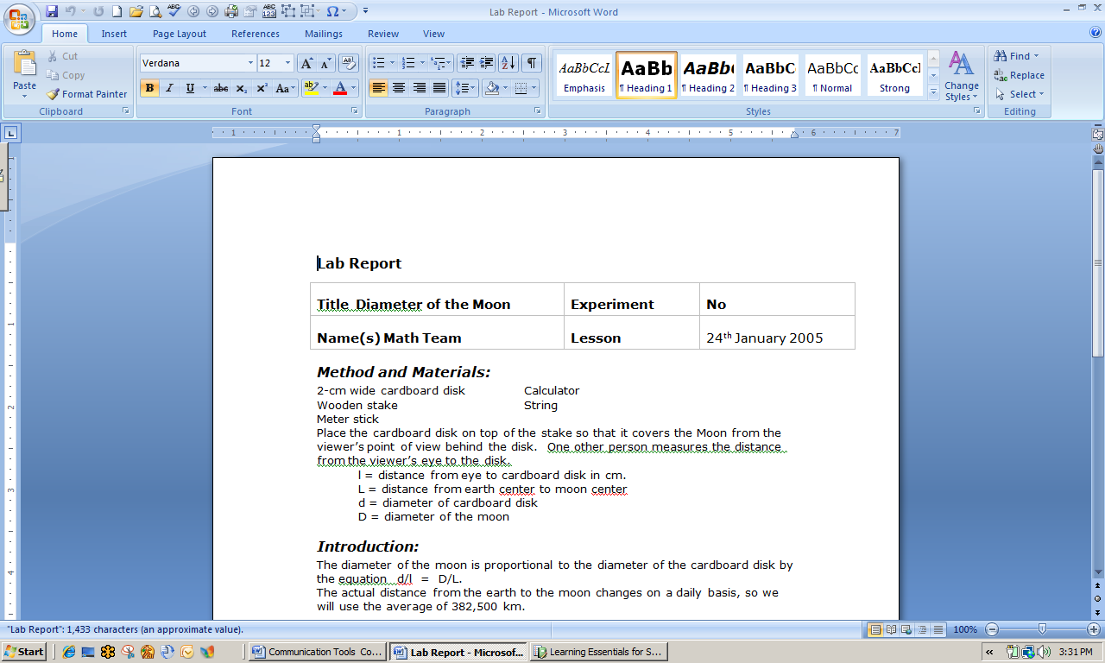 Learning Essentials Lab Report Template

1. Save as *[Your Name] Lab Report*. Close the file. Close Learning Essentials.

Test Your Knowledge

The tasks below were addressed in this unit. Be sure you understand the terms used and are able to complete the tasks listed.

Review Me – Using Learning Essentials for Teachers

1. Open Learning Essentials for Teachers. Use one of the included templates to create an essay test asking a question about PowerPoint.
2. Access a bar chart template. Make some changes to the included data. Change the title.
3. Design a handwriting practice using one of the included templates.
4. Create a project.
5. Create a Venn Diagram that looks at animals vs. plants.

Review Me – Using Learning Essentials for Teachers

1. Open Learning Essentials for Students. Create a book report cover slide for The Good Earth, by Pearl S. Buck, a novel of early China.
2. Start a “how to” essay on Opening MS Word in Windows Vista.
3. View 3-4 of the slides in the *Creating Charts and Graphs in Excel* tutorial.
4. Open the school timeline and fill in Monday’s schedule.
5. Start a press release on the benefits of Project Based Learning.

Curriculum Connections

Students use computers in the classroom as a tool for both productivity and learning. Integrating computer skills with the academic curriculum motivates and engages students, and prepares them for the technology age.

Below are a few ideas which can be used to integrate the skills covered in this unit into the academic curriculum.

Idea 1 – Using Learning Essentials for Teachers

* Create projects and a centralized location for all instructions, documents, rubrics, etc. that accompany it.
* Develop a budget for the History Club. Provide access to the budget to club officers.
* Use Learning Essentials rubrics to custom-design project assessments and communicate results to students.
* The math teacher takes advantage of links provided on Learning Essentials to access ideas for creative teaching of difficult concepts.
* The history teacher uses Learning Essentials to keep abreast of current professional development opportunities.

Idea 2 – Using Learning Essentials for Students

* Science students develop lab reports using Learning Essentials templates.
* History students access project documents and formative assessments; they complete assignments and submit to teacher for review.
* The Literary Club develops a program of work, a budget, and a presentation of activities to the local library using templates available through Learning Essentials.
* Biology students easily create charts to illustrate the effects of fertilizer on plant growth using Learning Essentials.
* The Science Club prepares a newsletter highlighting activities of the recently held science fair.

Use the space below to write down additional curriculum connections ideas:

|  |
| --- |
|  |
|  |
|  |
|  |
|  |
|  |
|  |
|  |
|  |
|  |
|  |
|  |
|  |
|  |
|  |
|  |
|  |
|  |
|  |
|  |

Unit 5: Using Audio and Video to Enhance Communications

Course Objectives

Add sounds to a PowerPoint presentation.

Explore Microsoft Zune as a means to enhance communications through social networks.

Add a movie clip to a PowerPoint presentation using Windows Media Player.

Using Audio and Video to Enhance Communications

The addition of an audio component presents real advantages for those learners accessing stories. The ability to listen to a story as well as read it enhances the development of the reading/learning strategies described earlier. Audio versions of a text present several advantages.

**Students are able to perceive the tone of a story and detect the emotions** of the people featured in a story; as a result they are better able to make perceptive inferences while reading.

**Student imaginations are stimulated** by the voices and the sounds featured in an audio clip; their abilities to construct mental images of what they are reading is greatly facilitated by hearing the story as they encounter the words of a text. This is especially crucial for struggling readers or readers who are English language learners.

**Students gain valuable assistance with difficult vocabulary**; they hear unfamiliar words pronounced that they would otherwise merely see in print. Hearing these words in context also assists readers with hypothesizing probable meanings. For struggling readers, as well as English language learners, hearing difficult words as they read provides immeasurable support as well as building a momentum for reading that is not constantly waylaid by challenging vocabulary.

**Student motivation to read is encouraged**; we all enjoy listening to stories and being "read to" brings back fond memories from our youth. It is no accident that books on tape are widely popular today, and listening to a talented reader interpreting the words on a page is a highly pleasurable experience. Students will find the drama of stories, and the emotions expressed by individuals interviewed in an audio clip, to be more dramatic and engaging than from merely encountering the words of a text.

Students who process information and ideas better through auditory rather than visual forms will find the **audio components to stories more definitely tailored to their learning styles**. They will have the option of both hearing and reading the stories, which will reinforce their learning.

**Students will have more variety in the means of their learning**. A clear advantage of technology is that students will have multiple methods of accessing useful information. The audio components to sound learning underscore unique features that technology can add to classroom routines. Students are able to draw upon multiple senses as they become truly immersed in learning situations.

Finally, **students learn about the specific genre of writing encompassed by audio stories**. These texts were written to be heard. As a result, the authors make choices in their writing that emphasize language and pacing that works especially well in a listening context. The texts are more powerful when listening is combined with reading.

Source: http://soundlearning.publicradio.org/standard/docs/about.shtml

Incorporating Audio and Video into PowerPoint

When you insert a sound on a slide, an icon Icon imagethat represents the sound file appears. To play the sound while you give your presentation, you can set the sound to start automatically when the slide is displayed, start on a mouse-click, start automatically but with a time delay, or play as part of an animation sequence. Some additional ways to use audio and video into PowerPoint presentations are

* Adding sounds from files on your computer, a network, or Microsoft Clip Organizer. You can also record your own sounds to add to a presentation or use music from a CD.
* Previewing a sound and also making the sound icon invisible during a slide show by hiding it or moving it off the slide into the gray area.
* Using a sound effect for emphasis by playing it once, which is the default behavior for sounds in Microsoft Office PowerPoint. There are options available to keep the sound playing until you stop it, or to play it for the duration of the presentation.

The Windows .Wav File Format

The .*wav* extension is the file format used by Windows to store sounds such as waveforms.

Waveform audio data sound files are unique in that they can be embedded in a document, while all other media file types are linked. All .wav files that are greater than 100KB are automatically linked by default.

Embedded file: Contained in a source file and inserted directly into a destination file.

Linked file: Created in a source file and inserted into a destination file, but maintaining a connection between the two files.

Linked files can be updated in the destination file when the source file is updated. The embedded file must be deleted and replaced.

Linking Sounds to PowerPoint

When you insert a linked sound file into PowerPoint, a link is created to the sound file's current location. If you later move the sound file to a different location, PowerPoint cannot locate it if you want the file to play. It is a good practice to copy the sounds into the same folder as your presentation before you insert the sounds.

Another way to be sure that your linked files are in the same folder as your presentation is to use the Package for CD feature. This feature copies all the files to one location (a CD or folder) with your presentation and automatically updates all the links for the sound files. When your presentation has linked files, you must copy the linked files as well as the presentation if you plan to give the presentation on another computer or send it to someone in e-mail.

Explore: Add and Manage Sounds in your Presentation

You and the other members of the math team have been working on a few PowerPoint slides to illustrate some facts and figures about the moon. You will be giving the presentation to a group of seniors at one of their annual banquets. A team member suggested that the presentation could use some “tunes.”

1. Open PowerPoint. Open the file *The Moon Adding Sounds.*  In the slide thumbnail pane, click slide 2.
2. In the **Insert** tab, **Media Clips** section, click the arrow below the Sound icon. Select Sound from Clip Organizer. The Clip Art pane will appear to the right of your slides, already formatted to search for and display sound clips.
3. Type moon in the **Search for**: box. What are the results?
4. Type wind in the **Search for**: box and select the Whistling Wind clip from the results. Select Automatically from the start options. A small speaker will appear in the middle of the slide. Move it to the lower right corner.
5. Right click the Whistling Wind sound clip and then select Copy. Open your student files and type Ctrl V to copy the sound clip to your files. Right click on the file name after it is copied and rename Whistling Wind.

**Note:**  You can preview a clip before adding it to your presentation. In the **Clip Art** task pane, **Results** box, move your mouse pointer over the clip's thumbnail. Click the arrow that appears, and then click Preview/Properties.

1. Open the cover slide and add the sound clip *Despertar* from your student files. When you click the Sound icon under the Insert tab, the Insert Sound dialog box opens. Go to the Student Files to locate the sound clip.

21st Century Communications with Microsoft Zune®

When used as a learning tool, the Zune player can make instruction more engaging so students are more likely to enjoy not only the content, but the process of learning. Teachers, students, and staff can easily distribute media to one or more people through multiple school computers or by beaming content Zune to Zune. For example, a student can easily share his or her video assignment with every high school student, almost instantly. The Zune player and associated software are designed for all types of users including those who demand products that are both highly useful and easy to use.

Some of the things your students can do with Zune include being able to

* Sync Zune Social with Live Messenger contacts and invite them to join the Zune social network.
* Receive a weekly e-mail digest of friends’ activities and real-time notifications of new messages and comments.
* See how many times a favorite music track has been played or added as a favorite.
* Purchase and download a favorite song heard on a radio station played on Zune.

Your Zune Profile page is all about YOU! It keeps track of your music listening habits—what artists and tunes you listen to the most, and what you have listened to most recently.

Your my Social is all about your friends and helps you keep track of what they have been listening to. It is also the site where you can invite others to be your friend, see all your friends, and see the artists and albums your friends have been playing.

Explore: Using Zune to Communicate and Share

1. Connect the Zune® Player to the Computer with the Sync Cable (into USB port). The Zune software will launch automatically and you should see the following on your screen.

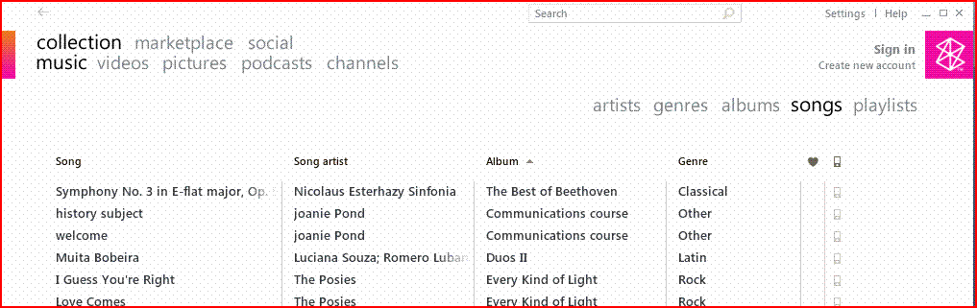

Zune Software Launch Screen

Sync is automatic and your new MP3 files will be placed into your music collection. You and others can now listen to your recorded audio files on the Zune Player or computer.

Using Windows Media Player® to Enhance Communications

Windows Media Player provides enhanced capabilities for working with multimedia applications within the Windows Vista environment. Your students can store and preview a variety of music, digital picture, and video applications. Media Player can sync with multiple devices such as Zune to provide you with real-time, accessible information and entertainment.

Explore: Add a movie

Mrs. Reddington found a video on the NASA website that showed the first moon landing and told the math team they should use it as part of their presentation for the senior citizens. The video was downloaded directly to a hard drive in Windows Media Player compatible format.

1. Open PowerPoint and the file, *The Moon Adding Video.* The team has added a new slide 2 and created a large space for video presentation.
2. In the **Insert** tab, **Media Clips** section, click the arrow below the Movie icon. Select Movie From File.
3. Select the file Moon Walk Video from your Student Files. Click OK and then select to have the movie started Automatically. A black box appears in the center of slide 2.
4. 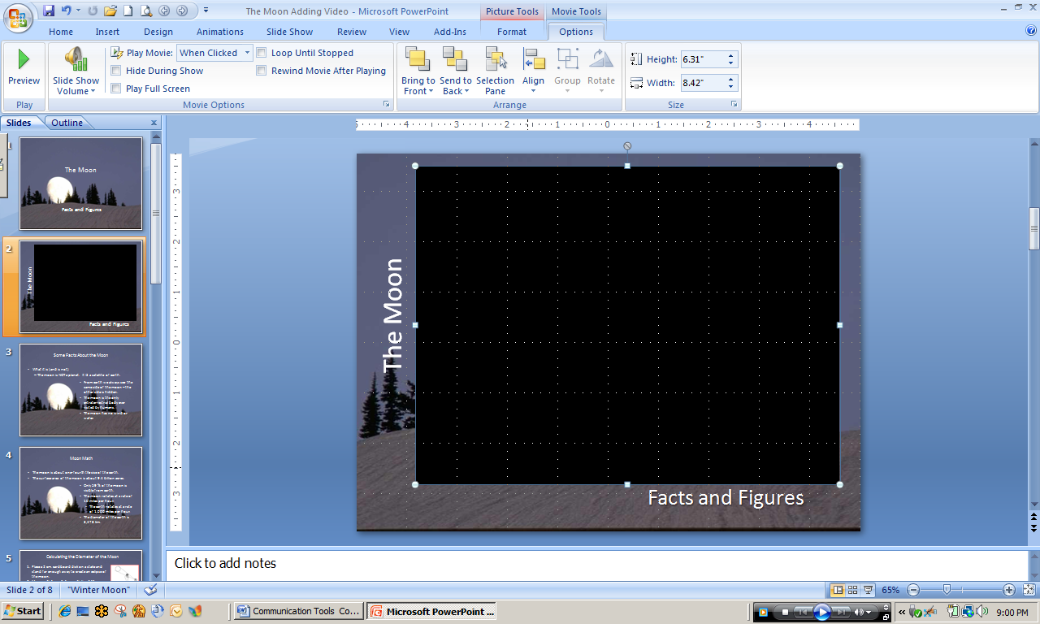Enlarge the box so that it fills most of the slide and resembles the one below.

PowerPoint with Video Inserted

1. In the **Slide Show** tab, **Start Slide Show** section, click From Current Slide. The slide show will start with slide 2.
2. Click anywhere on the black movie screen area to start the video. After you have seen some of it, hit Esc twice to stop the show and return to the PowerPoint design area.

You can play a movie so that it fills up the entire screen when you are giving your presentation, instead of playing it as part of a slide in your presentation; however, it might appear distorted when it is enlarged. You will always want to preview your movie, so that if the movie appears distorted or blurry, you can undo the full screen option. Generally, a small movie that is set to play full screen will not look good when it is enlarged.

1. If necessary, go to slide 2. Click anywhere on the movie screen area to open the **Movie Tools** tab. Click Options and go to the **Movie Options** section.
2. Select Play Full Screen.
3. View the slide show, starting from current slide.
4. De-select the option to play full screen.
5. Save the file as *[Your Name] Adding Video.* Close file.

Test Your Knowledge

The tasks below were addressed in this unit. Be sure you understand the terms used and are able to complete the tasks listed.

Review Me – Add Sounds to Your Documents

1. Locate the folder that typically stores sound files.
2. List the two types of most common sound files.
3. Name the sound file type that can be **embedded** in a PowerPoint slide.

Review Me – Use Sound in PowerPoint Presentations

1. Open the file *Robert Goddard Bio Sounds.* Add the sound clip, Boomy Blast, to slide 2 (from Student Files). Set the sound to play automatically when that slide is presented.
2. Change the option to play only When Clicked.
3. Run the Slide Show and click to engage sound.

Review Me – Add Music & Videos to Your Documents

1. Connect your Zune Player and Review available Music and Videos.
2. Sync the Zune and add any newly created files.
3. Go to Search the Internet resources for Science Videos and use Real Player Download feature to add a movie to your Movies folder. Re-Sync the Zune and locate the newly added Video.

Curriculum Connections

Students use computers in the classroom as a tool for both productivity and learning. Integrating computer skills with the academic curriculum motivates and engages students, and prepares them for the technology age.

Below are a few ideas which can be used to integrate the skills covered in this unit into the academic curriculum.

Idea 1 – Match Bird Species to their Songs

* Record the songs of the birds in your area.
* Take digital photos of each of the birds.
* Build a PowerPoint presentation with a slide for each bird and include its song.

Idea 2 – Learn about Local Plant Species

* Take digital pictures of various local plants or flowers.
* Record the common name of the plant.
* Then record the scientific (species) name of the plant.
* Create a slide show to run continuously and Package for CD for students to take home.

Idea 3 – Bring Geography to Life

* Search the internet for videos that highlight various cities in Italy.
* Find Maps of the Country and import them into a slide presentation.
* Add the video clips and create a virtual tour of the cities.

Additional resource: Create Your Own Podcast

http://windowshelp.microsoft.com/Windows/en-US/Help/0957d74a-ab72-421b-9d61-de415a6b32ba1033.mspx

Use the space below to write down additional curriculum connections ideas:

|  |
| --- |
|  |
|  |
|  |
|  |
|  |
|  |
|  |
|  |
|  |
|  |
|  |
|  |
|  |
|  |
|  |
|  |
|  |
|  |
|  |
|  |

Unit 6: Present and Publish

Unit Objectives

Insert audio and video clips to enhance a PowerPoint presentation.

Publish a presentation to a shared workspace for access by multiple audiences.

Record the presentation as a movie (WMV) file and share.

Create an electronic newsletter with graphics, hyperlinks, and sound clips.

Present and Publish

When a project nears completion, presentations are often the concluding activity as students prepare to share the results of their collaboration with others. Oral communication skills are a life-skill and part of most curricula.

Using presentation software such as MS Powerpoint reinforces those skills and helps ensure the effective communication of ideas. Students can present with greater confidence when using slides to summarize their content, color graphs to illustrate their ideas, and notes to remind them of support information to be shared. MS PowerPoint is the most popular example of a presentation software package.

PowerPoint also allows the presenter to share ideas clearly and concisely, supplemented by other types of data such as:

* Images
* Sounds
* Narrated recordings
* Music
* Video
* Links to Web sites
* Tables

As you have seen, PowerPoint provides many pre-designed templates to simplify the design process and give your slide show a consistent, professional look. When completed, the presentation can be prepared in a variety of ways including handouts or transparencies, packing it into a CD or saving it as a web page, or printing with speaker notes.

PowerPoint has many educational applications. Teachers can create instructional games to review material, prepare flash cards to reinforce class content, introduce new curricular topics with notes, media and links to web sites with interactive demonstrations, and produce professional presentations for colleagues and parents. More importantly, students can use PowerPoint to present projects, to review skills and content for tests and quizzes, to organize notes in outline form, and to engage in pre-writing as a part of the writing process.

Members of the class are able to create individual slides and join them in one large presentation. PowerPoint is a tool that promotes creative thinking and the synthesis of knowledge. Once students have interacted with the academic content during the slide show creation process, they are more apt to understand and recall it.

First, help your students identify the goals and purposes of their presentation. Then encourage them to:

* Become proficient at their topic.
* Organize ideas logically and express them clearly and simply.
* Use language appropriate for the audience.
* Practice to ensure confident and fluent delivery.
* Communicate interest and enthusiasm through voice quality and facial expression.
* Use eye contact to hold the audience’s interest and get nonverbal feedback.
* Speak clearly with appropriate volume.
* Add gestures to emphasize points.
* Maintain good posture.
* Use relevant visual aids to illustrate and support the topic.
* Make sure that visual aids are of a size and color to be seen clearly.
* Create visual aids that add understanding to the topic rather than distract.

As you will see, PowerPoint offers many tools to encourage both effective communication and the creation of quality visual aids.

Using Microsoft PowerPoint to Present the Project

As you begin using PowerPoint with your students, it is wise to have them focus first on the message to be communicated. They must collect, organize, and identify important information for the slides. Entering all text and data components first can help students remain focused on the content without getting distracted. Using a storyboard to plan is a helpful way to organize information and to decide where images and other media are needed to help communicate the message. They can also add presenter notes to the storyboard for use when developing the final presentation. Enjoy your students’ enthusiasm as they being to create and express themselves!

Explore: Combining Data from Multiple Sources into a Presentation

For more effective communication you can record a narration during a presentation. If you want to capture your own comments, the comments of your audience, or both during your presentation, you can turn on the narration before you begin to present.

Your students have already started putting their presentations together and are continuing to put on the finishing touches. The math students are working on their presentation of the moon and they want to rehearse the presentation by recording a narrative.

1. Open PowerPoint and the file *The Moon Audio and Video.* Make certain that slide 1 is showing on the screen.
2. In the **Slide Show** tab, **Set Up** section, click Record Narration. The **Record Narration** dialog box will appear as shown below.

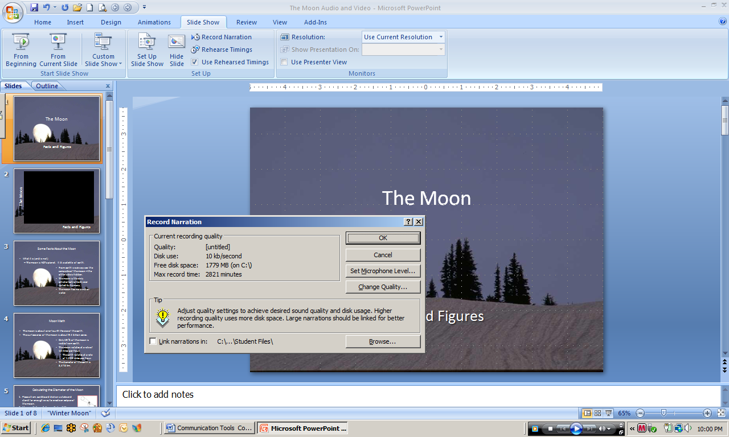

Record Narration dialog box

1. Click Set Microphone Level and follow the directions to set your microphone level. Click OK.

You will now be in Slide Show mode and ready to do a trial run of your presentation. Anything that you say to introduce or explain your slides, as well as anything that might be said by the audience, will be recorded.

1. Click each slide to advance through the presentation, making comments as you proceed.
2. Type Esc to stop the slide show at any time and return to the design screen.
3. Save the file as *[Your Name] The Moon Audio and Video.* Leave open for the next activity.

Explore: Record Presentation as a Video and Share.

Microsoft Community Clips provides an easy-to-use way to create custom-made videos and post them for others to see. If you do not already have MS Community Clips installed on your computer, download and install at <http://communityclips.officelabs.com/download.aspx>.

One you have installed Community Clips, you will have an additional tab available in the main menu ribbon, a Community Clips icon on Quick Access Toolbar, and an icon on the Windows Task Bar at the bottom right of your screen.

1. If necessary, download and install Community Clips. If necessary, open Power Point and the file *[Your] The Moon Audio and Video.*
2. Make certain that the first slide is showing in the design screen. Locate and click the Community Clips icon on the **Windows Task Bar** and then select Start Recording Application.
3. Select Microsoft PowerPoint – [Your] The Moon Audio and Video. If a screen appears informing you that recording has started, click OK to proceed.
4. As soon as possible, start the Slide Show by clicking the icon in the **Windows Task Bar**. You should see a red, wavy line across the bottom of the screen, which is an indicator that Community Clips is recording.
5. Continue to record throughout the slide show if there is time or stop the recording as indicated by your instructor. The Stop the Recording button is accessed through the Community Clips icon on the Windows Task Bar.
6. Windows Media Player will open to play what was recorded, with options to save, upload, or e-mail the file. Save the file as *[Your Name] Moon Clip.*

**Note:** After saving your clip, you may upload the file to Soapbox for sharing with others. You may also e-mail the clip to anyone.

1. E-mail the clip to a member of your team. Close the file.

Upload Video Files to Office Live Project Workspace

1. Open your Open Live project workspace.
2. Upload the file *[Your] Moon Clip.* Click Add Documents. Locate the file in your Student Files and click to select.
3. Click Open. The file will upload to your workspace. Close your workspace.

Sync Video Files to Zune

1. If necessary, remove your Zune from its USB port so it will sync automatically when reconnected. Remember to remove properly. Ask your instructor if you do not know how to remove hardware devices properly.
2. Locate the file *[Your Moon Clip]* if it is not open. Right click the file and select Copy. Open the Videos folder in the Documents folder. Type Ctrl V to copy the clip to the folder.
3. Plug Zune into the USB port of your computer. The video file will automatically be synced to Zune for sharing with others.

Putting It All Together – The Newsletter

The various teams in Mrs. Reddington’s science class have finished their research, developed PowerPoint presentations, created lab reports and other documents, and are now ready to create a newsletter. Microsoft tools make it easy to design and publish newsletters and other documents for distribution.

Explore: Creating a Newsletter Template in MS Word

A member of each team has been selected to develop the initial newsletter design and layout. They begin work as their other team members put the finishing touches on their respective presentations and other project artifacts.

1. Open MS Word. Click the Office button and then New. Locate and select Newsletters in the **Templates** menu on the left side.
2. Scroll through the newsletter choices to the end and select Quick and Easy E-mail Newsletter... Click Download. The newsletter template will open in Word and resemble the following.

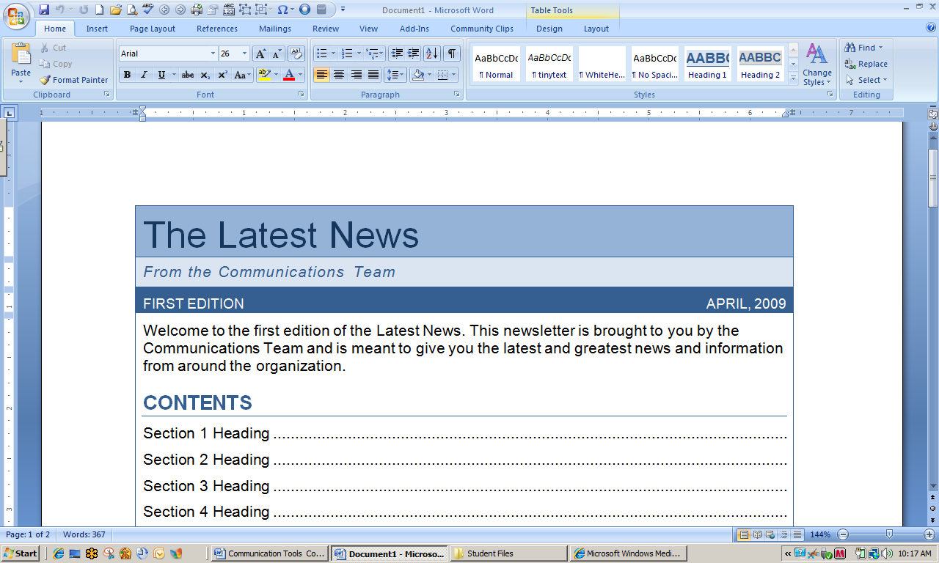

MS Word Newsletter Template

1. This particular template has a lot of features to make it easy to use. The Table of Contents is added automatically as you type heading information and then select Update Table. Type Caps Lock, go to section 1, select the text and type facts about the moon. Add the following headings for sections 2-4.

* Famous Space Pioneers
* Timeline of Space Travel
* How Rockets Work

1. Leave the heading **Additional Information** where it is, but delete the information (individually) for the remaining sections. You will have to highlight each area and delete.
2. Add the following information to the newsletter title and description areas.

Newsletter Title: Space Day Celebration

From Mrs. Reddington’s Science Class

Date: May 2009

Welcome to the 2009 Celebration of Space Day. This newsletter is brought to you by Mrs. Reddington’s Science Class to provide you with information about space travel and the results of our recent Space Day Project activities.

1. 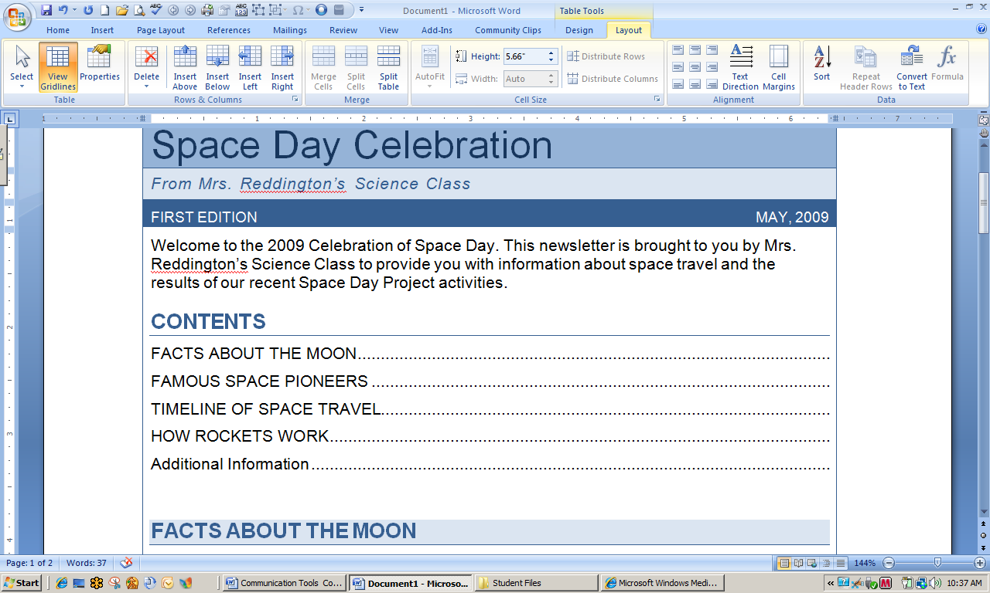Your screen should now resemble the following:

MS Word Newsletter Template with Added Headings

1. Save the file as *[Your Name] Newsletter Design*. Leave open for the next activity.

Explore: Adding Content to the Newsletter Template

Each of the teams has been asked to synthesize the information from their project activities to write a short piece for the newsletter. They are ready to submit their articles for publication.

1. If necessary, open MS Word and the file *[Your] Newsletter Design.* Open the document *Moon Newsletter Article.*  Highlight the text and copy it.
2. Toggle to open the newsletter template. Highlight the text in the first section of the newsletter and type Ctrl V. The moon article materials are now displayed in section 1 of the newsletter.

Add Video to the e-Newsletter

1. Create a space below the last line of text in the moon article. In the **Insert** tab, **Links** section, click Hyperlink.
2. In the **Text to display**: box, type Click Here to See a Video of the First Men on the Moon. In the **Look in**: box, locate your Student Files.
3. Select Moon Walk Video from the files listed in the box below. Click OK.

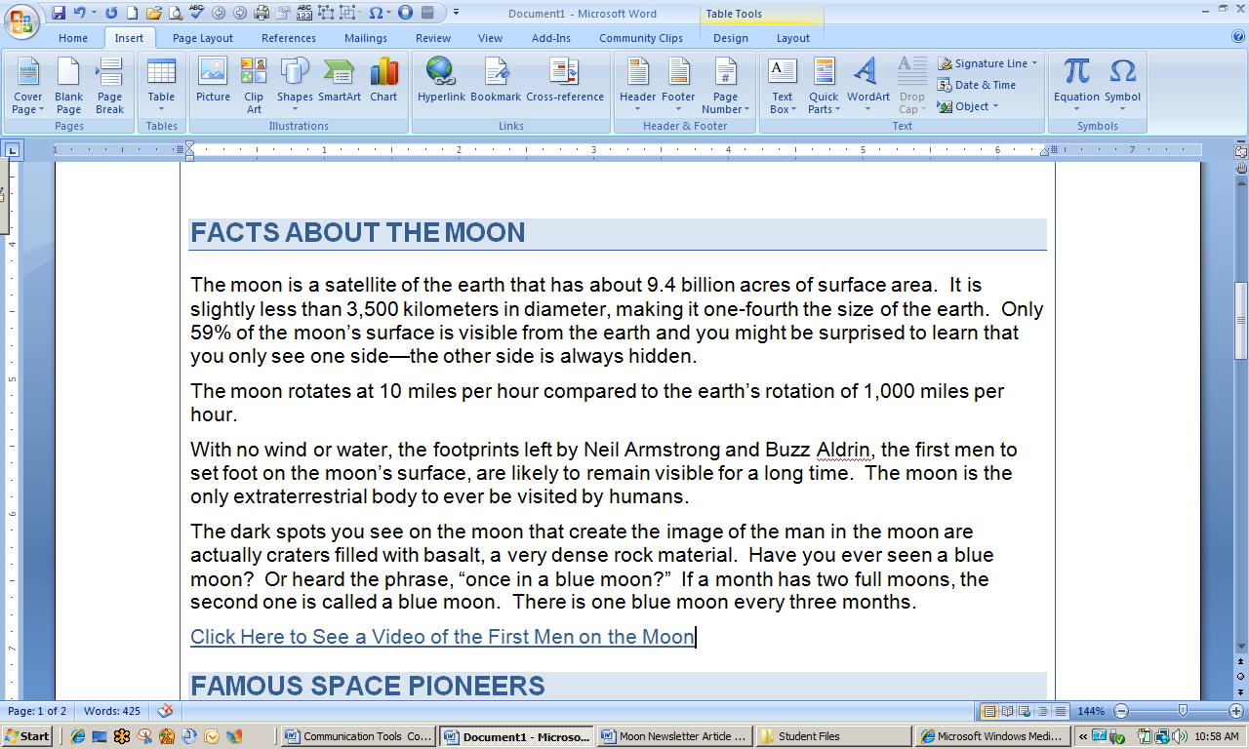

Newsletter with Added Video Clip

Adding a Picture to the e-Newsletter

1. Open the document *Goddard Newsletter Article.* Copy the text and paste to section 2, **Famous Space Pioneers**.
2. In the **Insert** tab, **Illustrations** section, click Picture. Locate the picture Goddard’s First Rocket in your Student Files. Select and then click Insert. The picture will be very large and will have to be resized and moved.
3. Click the picture to open the **Picture Tools** ribbon. Click Format, go to the **Arrange** section, and select Text Wrapping. Click Square. The picture can now be resized and moved. See if you can arrange the picture so your screen is similar to the one below.

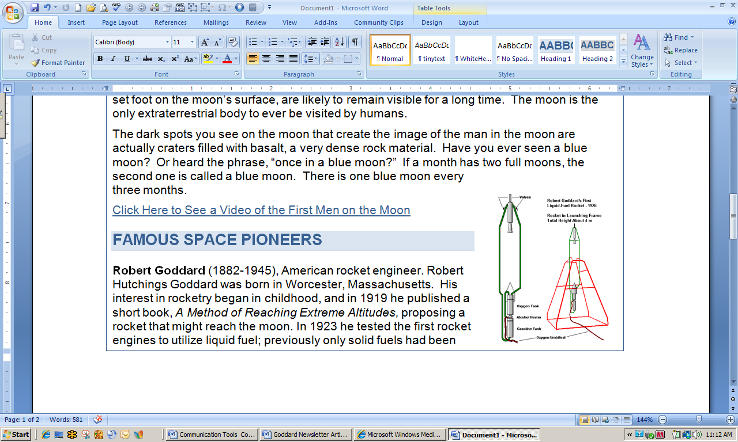

Newsletter with Added Picture

Adding Web-links to an e-Newsletter

If you are using downloaded information that contains links to other websites and information, you can display that information easily just by copying the saved information to your e-document. The links will display in color and underlined as they do by default, or however you may have them formatted to display. Since you are creating an e-newsletter, you can also include sound clips and other media that can be accessed by viewers.

1. Open the file *What is Thrust?* Copy and paste the text to section 4 of the newsletter, **How Rockets Work.** There are several links to websites showing in the copied text. Move the cursor over one of them and type Ctrl and then click to open the website.

Adding Sound to the e-Newsletter

1. Place the cursor in the upper right section of the **How Rockets Work** section. In the **Insert** tab, **Text** section, click **Object**. Click the Create from File tab.
2. Click Browse, go to your Student Files, and select the sound clip, Boomy Blast.
3. Click Insert. Make sure that the following two boxes are checked:
4. Link to File
5. Display as Icon
6. Click Change Icon. Type Rocket Blast in the **Caption:** box. You may also select a different icon. Click OK. Click OK.
7. Click the icon that now appears in your document to listen to the sound.
8. Save the file as *[Your Name] Newsletter Final* and close.

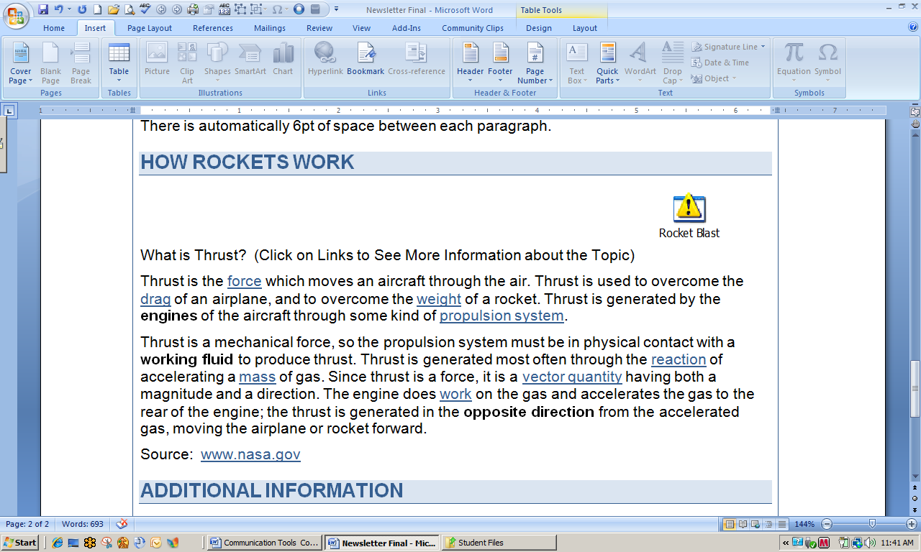

Newsletter with Added Web-links and Sound

TEst Your Knowledge

The tasks below were addressed in this unit. Be sure you understand the terms used and are able to complete the tasks listed.

Review Me – Presenting with PowerPoint

* 1. Open PowerPoint. Open the document, *Interview with Former Astronaut.* Create a new PowerPoint presentation using a template of your choice (2-3 slides only)
  2. Search for a sound file in the Clip Art Organizer and add to one of the slides.
  3. Search for a clip art graphic and add to one of the slides.
  4. Save the file as *[Your Name] Interview* and close. Leave Power Point open.

Review Me – Adding Video to a PowerPoint

1. Create a new cover slide for a presentation about the Alaskan brown bear.
2. Add a second slide. Insert the video clip, *Brown Bear* from your student files.
3. Explore various changes in the format of the presentation.
4. Save the file as *[Your Name] Brown Bear* and close. Close Power Point.

Review Me – Creating a Newsletter

1. Open Word. Create a newsletter using the School Newsletter template.
2. Change the title to add your name.
3. Create an article #1 titled *Facts about the Moon.* Use the document of the same name to write a short paragraph.
4. Delete the picture of the apple in the first column. Insert the picture *Full Moon* from your Student Files. Resize and move the picture as necessary (text wrapping).
5. Add a caption.
6. Add a hyperlink to the NASA website – http://www.nasa.gov.
7. Save the file as *[Your Name] Newsletter Practice*. Close the file. Close Word.

Curriculum Connections

Students use computers in the classroom as a tool for both productivity and learning. Integrating computer skills with the academic curriculum motivates and engages students, and prepares them for the technology age.

Below are a few ideas which can be used to integrate the skills covered in this unit into the academic curriculum.

Idea 1 – Presentations Foster Higher Order Thinking and Social Skills

* Biology students must synthesize large amounts of data into clear, concise descriptions in order to present the concepts of plant structure to 4th and 5th graders.
  + Students are evaluated on both the accuracy and completeness of the content and the strength of the oral presentations.
* Math students condense a week of activities focused on the Pythagorean Theorem into a 10 minute presentation.
  + Students are evaluated on the presentation design and their demonstrated skills in working through the group process.
* Language Arts students give a PowerPoint book report, creating easy-to-understand narratives of the characters and plot. They exercise good judgment sorting through many clip art and photo examples to select appropriate illustrations.

Idea 2 – Using Newsletters and Other Electronic Media to Communicate

* Social studies students have completed a one-week project on the Constitutional Convention. They create an electronic newsletter to highlight what they have learned that can be sent via e-mail to parents and others.
* Agriculture students create a “how to” video on transplanting garden plants, and send it via Zune or as a podcast.
* 9th grade Language Arts students create a “how to” PowerPoint on writing haiku, record it using Community Clips, and upload it for others to access.

Use the space below to write down additional curriculum connections ideas:

|  |
| --- |
|  |
|  |
|  |
|  |
|  |
|  |
|  |
|  |
|  |
|  |
|  |
|  |
|  |
|  |
|  |
|  |
|  |
|  |
|  |

Unit 7: Tying It All Together

Project Objectives

Design Effective Cooperative Learning Experiences for Learners of Varying Ability Levels

Select Appropriate Microsoft Tools and Applications to Aid the Facilitation of Project Based Learning.

Tying It All Together

Being able to implement Project Based Learning is not always easy. There isn’t one model to follow, or one right way to “do” Project Based Learning; however, as noted in the Introduction, there are ways to plan, organize, and facilitate PBL in order to ensure that all students gain the maximum from the learning experience.

Case Studies

Select a partner. Examine each of the following case studies and select one for in-depth exploration. Based on what you have learned and your own personal experiences, conceptualize a project experience and identify the Microsoft tools that would enhance its implementation.

Explore: Case Study #1

Mrs. Hilton teaches 5th grade math in a small rural school district. Her class consists of 14 students, one of whom leaves the class after morning exercises for a self-contained classroom. Of the other 13

* Three are working above grade level.
* Three are working at grade level.
* Five are working at low 4th grade level.
* Two are working below 4th grade level.

With the exception of the three students that are working above grade level, all are having difficulty seeing the equivalence of fractions, decimals, and percents. A significant portion of the state standardized test for 5th grade covers these areas.

Mrs. Hilton has access to a mobile laptop with 30 Tablet PCs, MS Office 2007, high speed Internet connection, Zune players, and Learning Essentials for Teachers and Students.

Brainstorm with your partner and complete the following table. Remember, interdisciplinary projects provide tremendous opportunities for reinforcement of content.

|  |  |
| --- | --- |
| **Case Study #1: 5th Grade Mathematics** | |
| **Project Idea(s)**  What will students investigate or do during the project? What is the central question? What problem are they trying to solve? |  |
| **Major Objectives**  Identify 2-4 academic objectives, a few process objectives, and a few technology objectives. |  |
| **Group Structure**  Are there any ways to structure the groups to maximize learning for all students? |  |
| **Product(s)/Artifact(s)**  What will students have “to show” for their efforts? |  |
| **Duration** |  |
| **Microsoft Tools**  What software and application tools will be useful in the project, both for the teacher and the students? |  |
| **Communication of Results Through**  How will the product(s)/artifact(s) be displayed to others? |  |
| **Assessment Ideas**  In what ways will students be assessed so that learning can be accurately measured? |  |
| **How is this project student-centered vs. teacher-centered?** | |

Explore: Case Study #2

Mrs. Hilton also teaches a 7th grade pre-algebra course. There are 17 students in the class. A major barrier is understanding the concept of negative numbers for all operations (adding, subtracting, multiplying, and dividing). Of the 17 students

* One is gifted, but an underachiever because he gets bored easily and does not complete all of his assignments.
* Four (all girls) are borderline gifted and high achievers. One struggles with negative numbers and gives up easily.
* Four are working at grade level.
* Three are working just slightly below grade level, but are really struggling with negative numbers.
* Two are working at a 5th grade level. They have difficulty with basic mathematics operations.
* Three are failing because they do not do any of their assignments.

The class has been completing worksheets on negative numbers for several weeks. When it comes to test time, though, they do not do very well. Over half the class is failing this portion of the curriculum.

Brainstorm with your partner and complete the following table. Remember, interdisciplinary projects provide tremendous opportunities for reinforcement of content.

|  |  |
| --- | --- |
| **Case Study # 2: 7th Grade Mathematics** | |
| **Project Idea(s)**  What will students investigate or do during the project? What is the central question? What problem are they trying to solve? |  |
| **Major Objectives**  Identify 2-4 academic objectives, a few process objectives, and a few technology objectives. |  |
| **Group Structure**  Are there any ways to structure the groups to maximize learning for all students? |  |
| **Product(s)/Artifact(s)**  What will students have “to show” for their efforts? |  |
| **Duration** |  |
| **Microsoft Tools**  What software and application tools will be useful in the project, both for the teacher and the students? |  |
| **Communication of Results Through**  How will the product(s)/artifact(s) be displayed to others? |  |
| **Assessment Ideas**  In what ways will students be assessed so that learning can be accurately measured? |  |
| **How is this project student-centered vs. teacher-centered?** | |

Explore: Case Study # 3

Mr. Walters notices that most of the 7th grade science students cannot write a good lab report. He has often evaluated the reports based on the science content, but he has been troubled by the poor quality of the information as it is presented.

He speaks with the Language Arts teacher who indicates that the students are actually quite good writers. They come to the conclusion that the students are just “leaving the writing skills” behind when they are in science class.

Mr. Walters tries providing more structure for subsequent reports, but with little noticeable improvement in what students turn in.

The next content are to be covered is cell structure. The students are the same students that Mrs. Hilton has in the pre-algebra course.

Brainstorm with your partner and complete the following table. Remember, interdisciplinary projects provide tremendous opportunities for reinforcement of content.

|  |  |
| --- | --- |
| **Case Study # 3: 7th Grade Science** | |
| **Project Idea(s)**  What will students investigate or do during the project? What is the central question? What problem are they trying to solve? |  |
| **Major Objectives**  Identify 2-4 academic objectives, a few process objectives, and a few technology objectives. |  |
| **Group Structure**  Are there any ways to structure the groups to maximize learning for all students? |  |
| **Product(s)/Artifact(s**)  What will students have “to show” for their efforts? |  |
| **Duration** |  |
| **Microsoft Tools**  What software and application tools will be useful in the project, both for the teacher and the students? |  |
| **Communication of Results Through**  How will the product(s)/artifact(s) be displayed to others? |  |
| **Assessment Ideas**  In what ways will students be assessed so that learning can be accurately measured? |  |
| **How is this project student-centered vs. teacher-centered?** | |

Appendix: Resources for Project Based learning

Select Online Resources for Project Based Learning

The Center for Innovation in Engineering and Science Education (CIESE) has a website with multiple projects that involve collaboration with classrooms across the country and globe. The curricular emphases of the projects could be expanded at the local level to include mathematics and social studies. Also, availability of multiple projects and ongoing data collection activities enables integration over a time span.

<http://www.k12science.org/collabprojs.html>

Sample projects include the areas of human genetics, water quality, monitoring the sun, daily water use, and human impact on the oceans.

The Center also has project ideas for collection of “real time data” in climatology.

<http://www.k12science.org/realtimeproj.html>

The US Census Bureau provides teaching resources and data; older students can access Census datasets.

<http://www.census.gov/dmd/www/teachers.html>

The Math Library of the Drexel School of Education publishes a website with numerous collaborative and other projects. The projects have online data entry and access to data from other participating schools. Non-collaborative, classroom projects are also available.

<http://mathforum.org/workshops/sum96/data.collections/datalibrary/>

The Energy Information Administration publishes weekly updates of retail gas prices by nation, region, and state.

<http://www.eia.doe.gov/oil_gas/petroleum/data_publications/wrgp/mogas_home_page.html>

Annenberg Media has a global wildlife migration tracking project that can be used year-round.

<http://www.learner.org/jnorth/Sitemap.html>

The Blue Web'N: A Library of Blue Ribbon Learning Sites on the Web   
<http://www.kn.pacbell.com/wired/bluewebn/>

Education World: Collaborative Projects K-12  
<http://www.education-world.com/projects/index.shtml>

Global School House Internet Project Registry  
<http://www.globalschoolhouse.org/pr/>

Handbook of Engaged Learning Projects<http://www-ed.fnal.gov/help/index.html>

Starting in the Middle 2000: Integrated Project Designs for Idaho Middle Level Students, Volume II<http://www.nwrel.org/ecc/middle_2000/>

References on Project Based Learning

Abramson, S., Robinson, R., & Ankenman, K. (1995). Project work with diverse students: Adapting curriculum based on the Reggio Emilia approach. *Childhood Education*, 71(4), 197–202.

Anderman, L.H., & Midgley, C. (1998). *Motivation and middle school students* [ERIC digest]. Champaign, IL: ERIC Clearinghouse on Elementary and Early Childhood Education. Retrieved June 25, 2002, from <http://www.ericfacility.net/ericdigests/ed421281.html>

Banks, J.C. (1997). Creating and assessing performance-based curriculum projects: A teacher’s guide to project-based learning and performance assessment. Edmonds, WA: CATS (Creative Activities and Teaching Strategies).

Blank, W. (1997). Authentic instruction. In W.E. Blank & S. Harwell (Eds.), *Promising practices for connecting high school to the real world* (pp. 15–21). Tampa, FL: University of South Florida. (ERIC Document Reproduction Service No. ED407586)

Bonthron, S., & Gordon, R. (Eds.). (1999). *Service-learning and assessment: A field guide for teachers*. Montpelier, VT: Vermont Department of Education, National Service-Learning and Assessment Study Group. Retrieved July 10, 2002, from <http://www.vermontcommunityworks.org/cwpublications/slassessguide/slassessguide.html>

Bottoms, G., & Webb, L.D. (1998). *Connecting the curriculum to “real life.”* Breaking Ranks: *Making it happen*. Reston, VA: National Association of Secondary School Principals. (ERIC Document Reproduction Service No. ED434413)

Brewster, C., & Fager, J. (2000). *Increasing student engagement and motivation: From time-on-task to homework*. Portland, OR: Northwest Regional Educational Laboratory. Retrieved June 25, 2002, from <http://www.nwrel.org/request/oct00/index.html>

Bryson, E. (1994). Will a project approach to learning provide children opportunities to do purposeful reading and writing, as well as provide opportunities for authentic learning in other curriculum areas? Unpublished manuscript. (ERIC Document Reproduction Service No. ED392513)

Challenge 2000 Multimedia Project. (1999). *Why do project-based learning?* San Mateo, CA: San Mateo County Office of Education. Retrieved June 25, 2002, from <http://pblmm.k12.ca.us/PBLGuide/WhyPBL.html>

Clark, R.J. (1999). *Advocating for culturally congruent school reform: A call to action for Title IX Indian education programs & parent committees*. Portland, OR: Northwest Regional Educational Laboratory, Comprehensive Center Region X. Retrieved June 25, 2002, from <http://www.nwrac.org/congruent/index.html>

Dev, P.C. (1997). Intrinsic motivation and academic achievement: What does their relationship imply for the classroom teacher? *Remedial and Special Education*, 18(1), 12–19.

Dickinson, K.P., Soukamneuth, S., Yu, H.C., Kimball, M., D’Amico, R., Perry, R., et al. (1998). *Providing educational services in the Summer Youth Employment and Training Program* [Technical assistance guide]. Washington, DC: U.S. Department of Labor, Office of Policy & Research. (ERIC Document Reproduction Service No. ED420756)

Edwards, C.P., Gandini, L., & Forman, G.E. (Eds.). (1993). The hundred languages of children: The Reggio Emilia approach to early childhood education. Norwood, NJ: Ablex.

Edwards, K.M. (2000). *Everyone’s guide to successful project planning: Tools for youth*. Portland, OR: Northwest Regional Educational Laboratory.

Edwards, K.M., & Schwendiman, J. (2000). *Building relationships, structures and bridges: Teaching tools for service learning* [Workshop materials]. Portland, OR: Northwest Regional Educational Laboratory.

Green, A. (1998). *What is project-based learning?* San Antonio, TX: National Institute for Literacy Fellowship Project. Retrieved June 25, 2002, from [http://members.aol.com/CulebraMom/pblprt.html](http://members.aol.com/culebramom/pblprt.html)

Harwell, S. (1997). Project-based learning. In W.E. Blank & S. Harwell (Eds.), *Promising practices for connecting high school to the real world* (pp. 23–28). Tampa, FL: University of South Florida. (ERIC Document Reproduction Service No. ED407586)

Harwell, S., & Blank, W. (1997). Connecting high school with the real world. In W.E. Blank & S. Harwell (Eds.), *Promising practices for connecting high school to the real world* (pp. 1–4). Tampa, FL: University of South Florida. (ERIC Document Reproduction Service No. ED407586)

Herman, J.L., Aschbacher, P.R., & Winters, L. (1992). *A practical guide to alternative assessment*. Alexandria, VA: Association for Supervision and Curriculum Develop-ment. (ERIC Document Reproduction Service No. ED352389)

Houghton Mifflin. (n.d.). *Houghton Mifflin’s project-based learning space: Background knowledge and theory*. New York, NY: Author. Retrieved July 9, 2002, from <http://college.hmco.com/education/pbl/background.html>

Jobs for the Future. (n.d.). *Using real-world projects to help students meet high standards in education and the workplace* [Issue brief]. Boston, MA: Author, & Atlanta, GA: Southern Regional Education Board. Retrieved July 9, 2002, from http://www.jff.org/pdfs%20and%20downloads/SREB.pdf

Kadel, S. (1999, November 17). Students to compile county’s oral history. *Hood River News*. Retrieved July 9, 2002, from [http://www.gorgenews.com/Archives/HRarch/HR121.htm](http://www.gorgenews.com/archives/hrarch/hr121.htm)

Karlin, M., & Viani, N. (2001). *Project-based learning*. Medford, OR: Jackson Education Service District. Retrieved July 9, 2002, from <http://www.jacksonesd.k12.or.us/it/ws/pbl/>

Katz, L.G. (1994). *The project approach* [ERIC digest]. Urbana, IL: ERIC Clearinghouse on Elementary and Early Childhood Education. (ERIC Document Reproduction Service No. ED368509)

Katz, L.G., & Chard, S.C. (1989). *Engaging children’s minds: The project approach*. Norwood, NJ: Ablex.

Katz, L.G., & Chard, S.C. (1998). *Issues in selecting topics for projects* [ERIC digest]. Champaign, IL: ERIC Clearinghouse on Elementary and Early Childhood Education. Retrieved July 10, 2002, from <http://ericps.crc.uiuc.edu/eece/pubs/digests/1998/katzpr98.html>

Lumsden, L.S. (1994). *Student motivation to learn* (ERIC Digest No. 92). Eugene, OR: ERIC Clearinghouse on Educational Management. Retrieved July 10, 2002, from <http://www.ericfacility.net/ericdigests/ed370200.html>

Martin, N., & Baker, A. (2000). *Linking work and learning toolkit*. Portland, OR: worksystems, inc., & Portland, OR: Northwest Regional Educational Laboratory.

Moursund, D., Bielefeldt, T., & Underwood, S. (1997). *Foundations for The Road Ahead: Project-based learning and information technologies*. Washington, DC: National Foundation for the Improvement of Education. Retrieved July 10, 2002, from <http://www.iste.org/research/roadahead/pbl.html>

Nadelson, L. (2000). Discourse: Integrating problem solving and project-based learning in high school mathematics. *Northwest Teacher*, 1(1), 20. Retrieved July 10, 2002, from http://www.nwrel.org/msec/nwteacher/spring2000/textonly/discourse.html

Northwest Regional Educational Laboratory. (1996). *Integrated workplace learning project: Teacher reference guide*. Portland, OR: Author.

Rankin, B. (1993). Curriculum development in Reggio Emilia: A long-term curriculum project about dinosaurs. In C.P. Edwards, L. Gandini, & G.E. Forman (Eds.), *Hundred languages of children: The Reggio Emilia approach to early childhood education* (pp. 189–211). Norwood, NJ: Ablex.

Reyes, R. (1998). *Native perspective on the school reform movement: A hot topics paper*. Portland, OR: Northwest Regional Educational Laboratory, Comprehensive Center Region X. Retrieved July 10, 2002, from <http://www.nwrac.org/pub/hot/native.html>

Scaglione, J. (1997). The real world. In W.E. Blank & S. Harwell (Eds.), *Promising practices for connecting high school to the real world* (pp. 7–12). Tampa, FL: University of South Florida. (ERIC Document Reproduction Service No. ED407586)

Steinberg, A. (1998). Real learning, real work: School-to-work as high school reform. New York, NY: Routledge.

Stites, R. (1998). *What does research say about outcomes from project-based learning?* Retrieved July 10, 2002, from Challenge 2000 Multimedia Project, San Mateo County Office of Education Web site: <http://pblmm.k12.ca.us/PBLGuide/pblresch.htm>

Thomas, J.W. (1998). *Project based learning overview*. Novato, CA: Buck Institute for Education. Retrieved July 10, 2002, from <http://www.bie.org/pbl/overview/index.html>